[1] Google Maps Add API (POST)

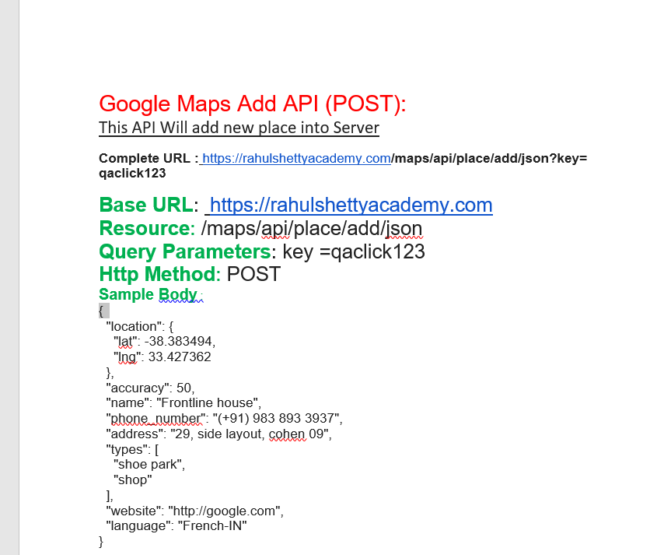

Postman. Create this Postman request:-

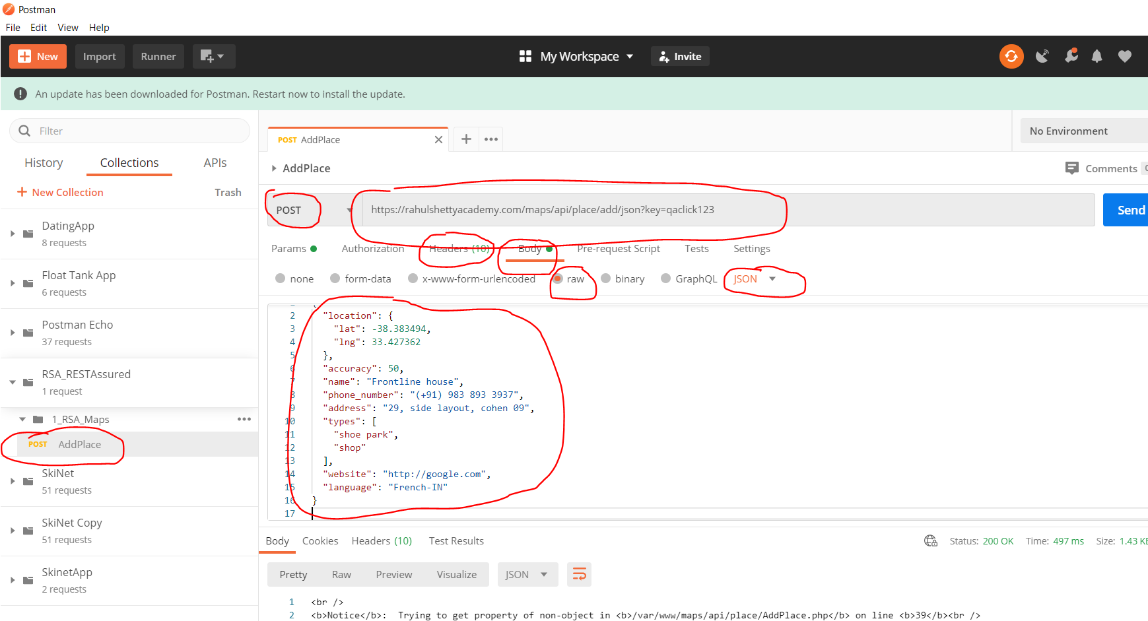

Click ‘Send’ and see response:-

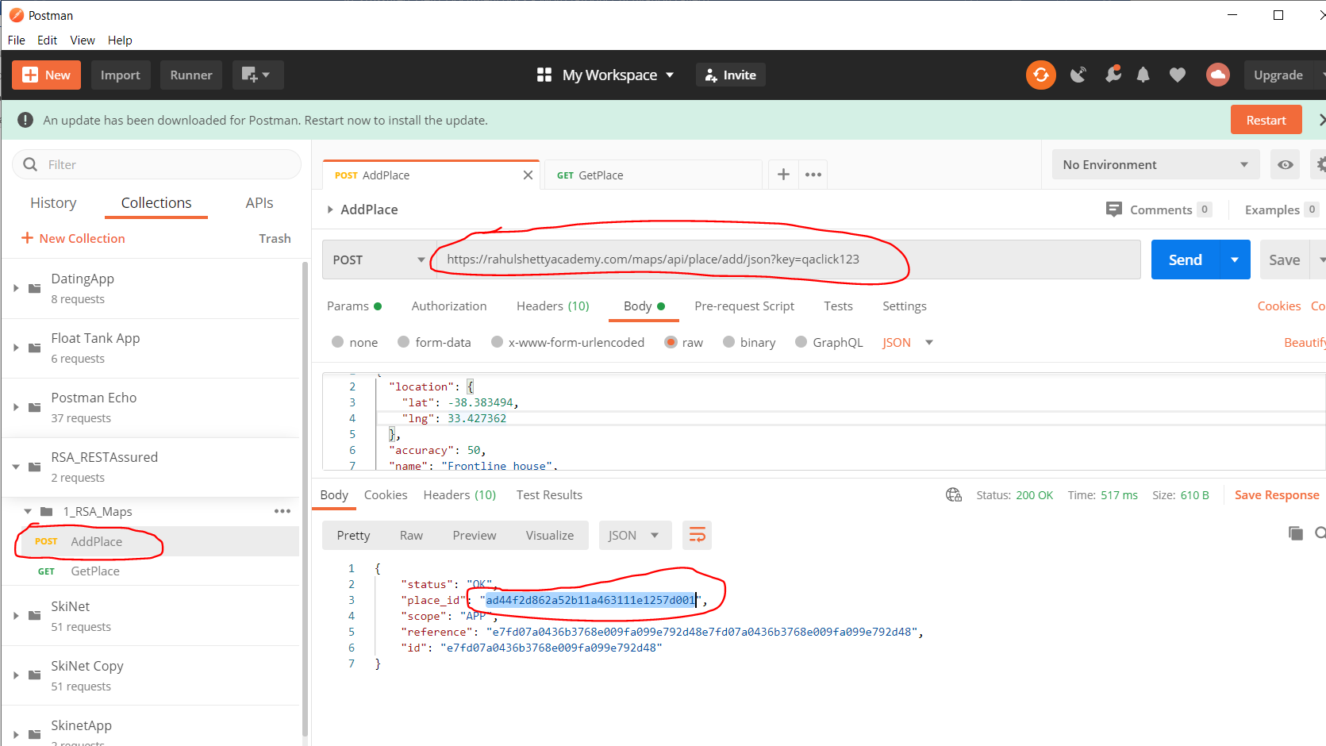

[2] Google Maps GET API (GET)

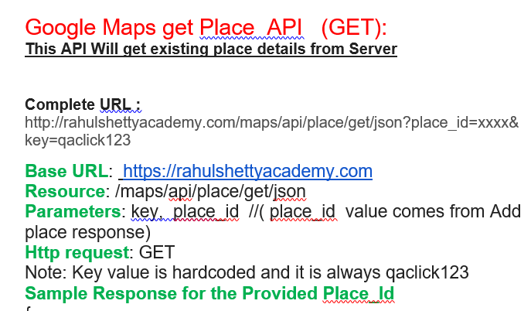

Create the Postman Request:-

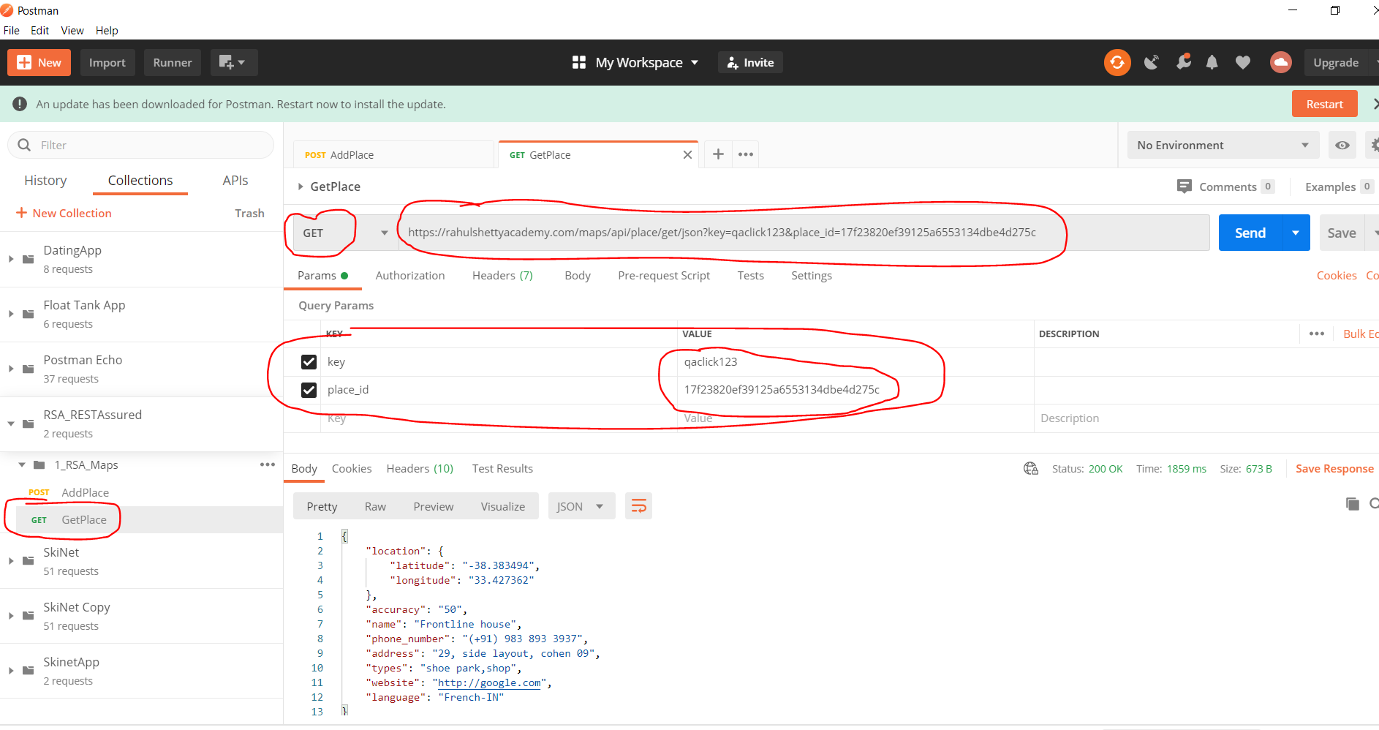

Click ‘Send’ and see response:-

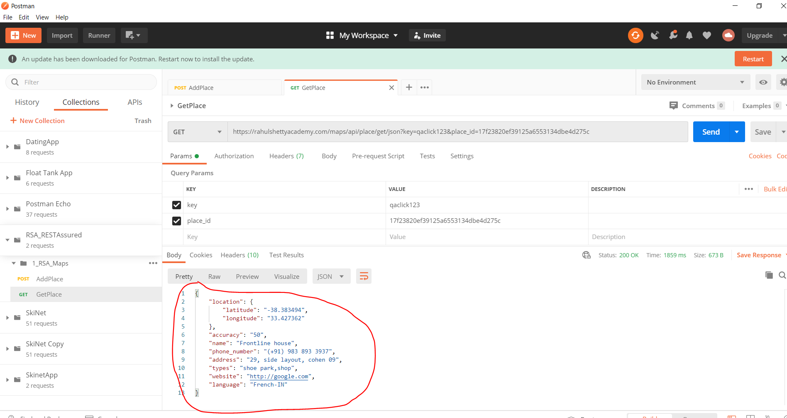

[3] Google Maps DELETE API (DELETE)

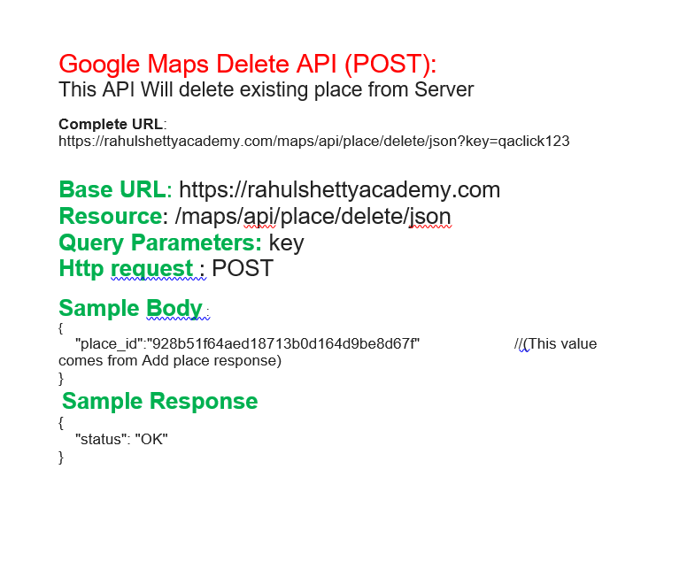

Create this Postman Request:-

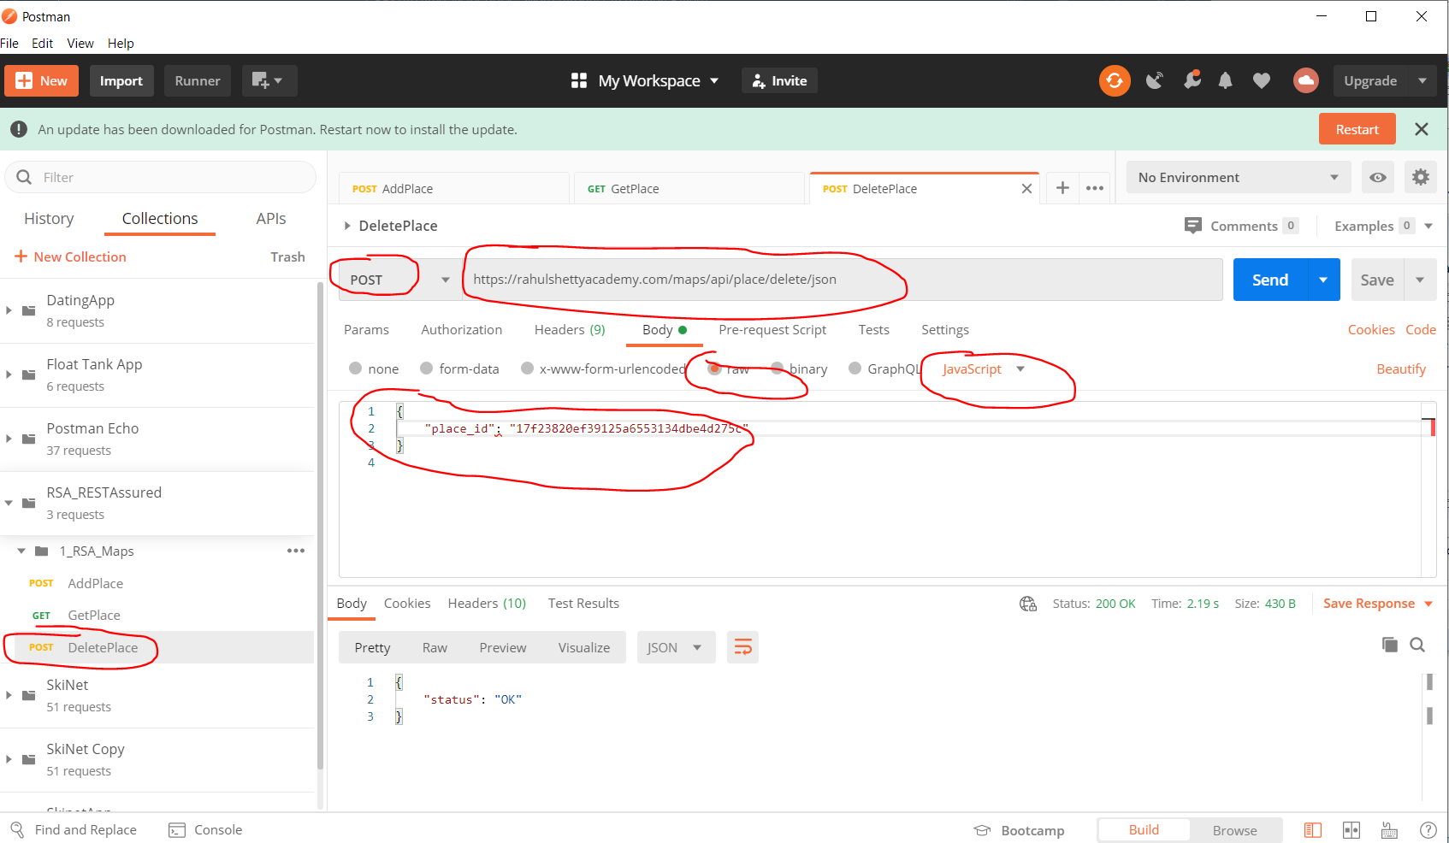

You can also change the POST to DELETE. They do the same thing.

[4] Google Maps Update API (PUT)

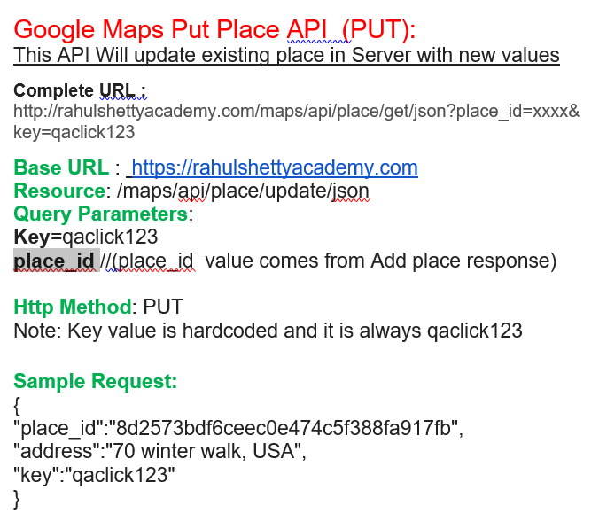

Create a new Postman request:-

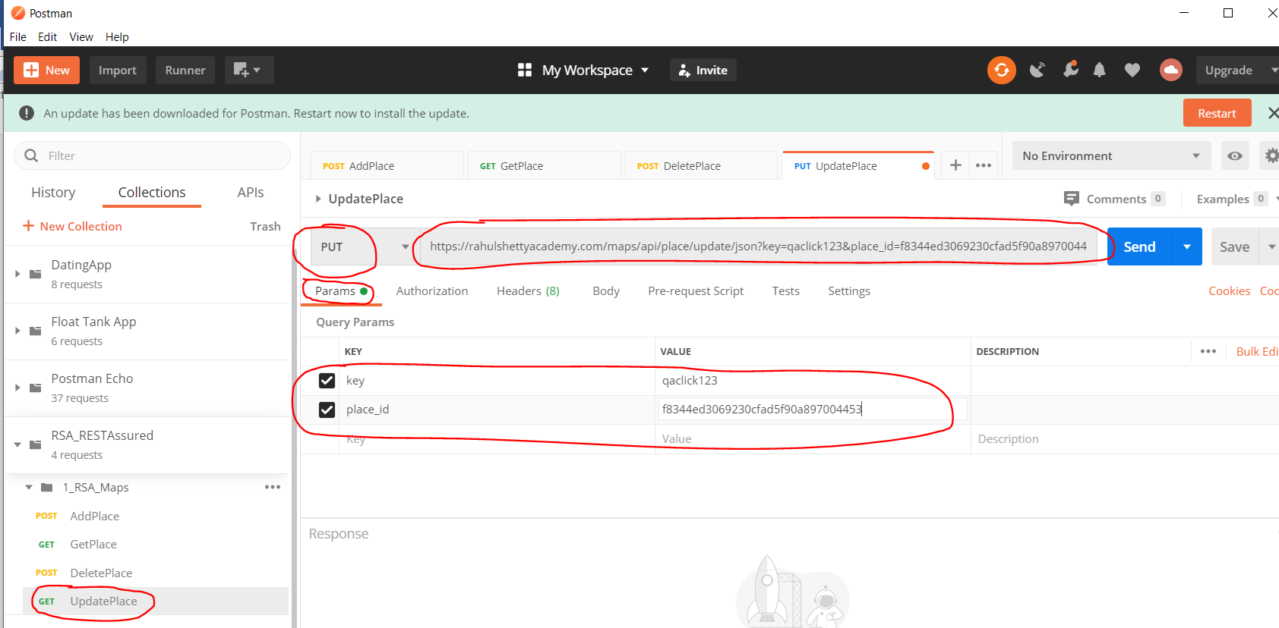

Also, add this to the ‘Body’ section tab:-

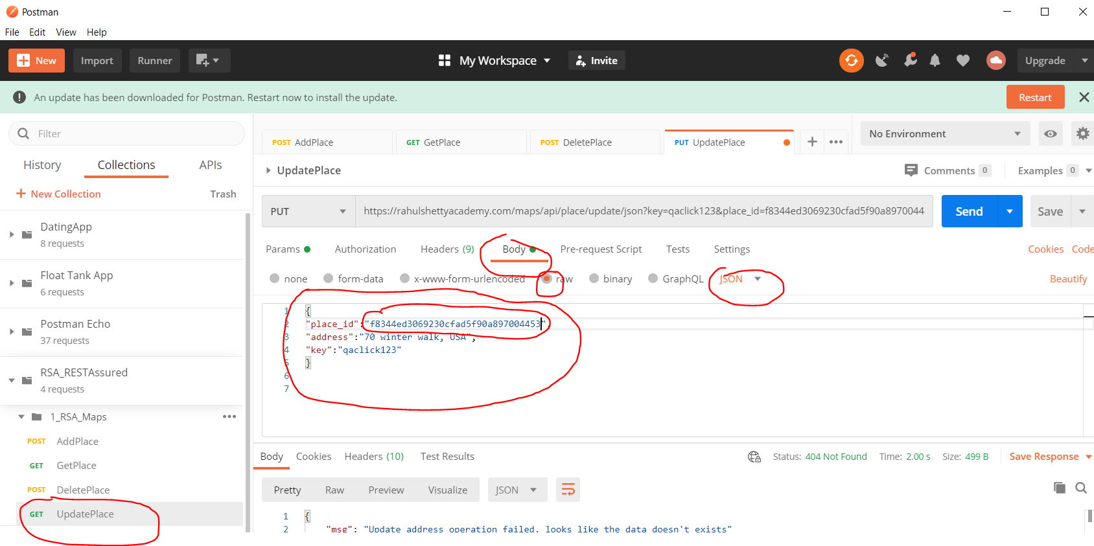

Click ‘Send’ button and see response:-

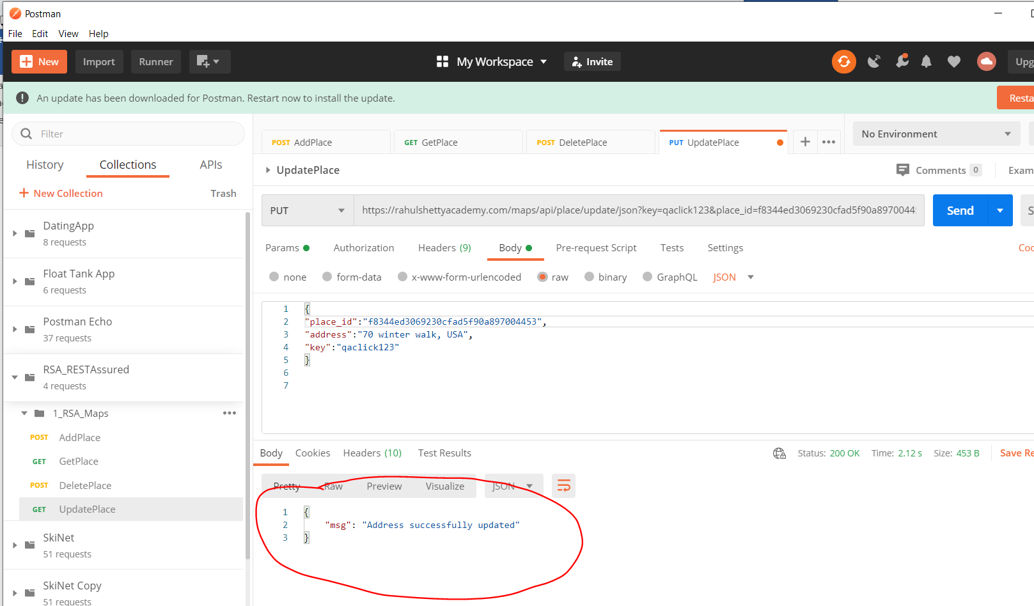

**Rest Assured Setup**

Download Java:-

<https://www.oracle.com/uk/java/technologies/javase/javase-jdk8-downloads.html>

Download this:-

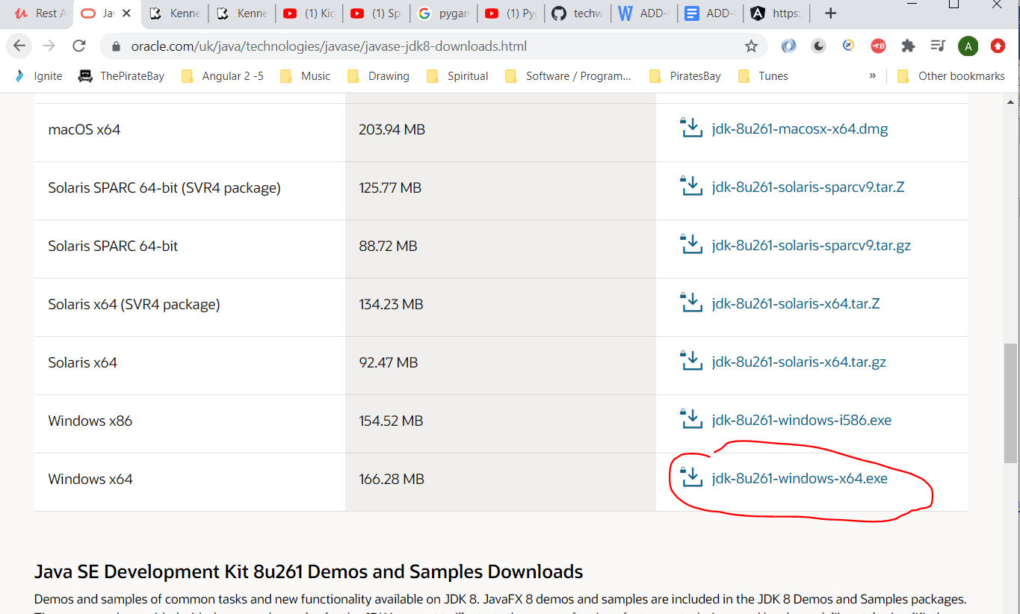

Install the downloaded .exe

Set JAVA as an environment variable:-

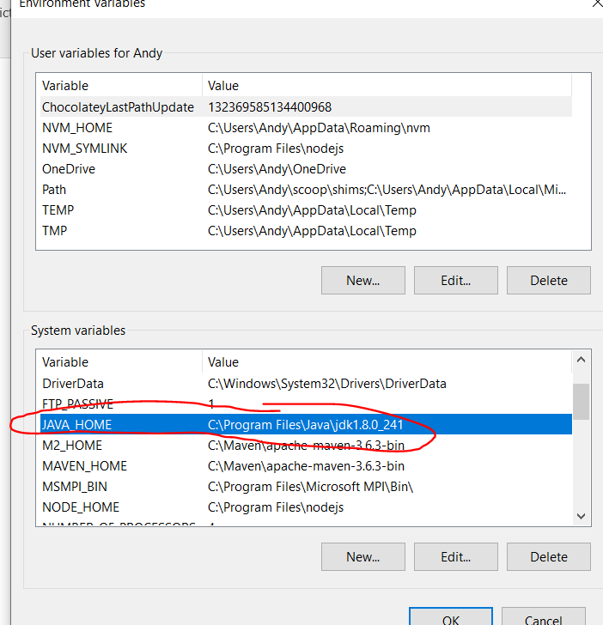

Which is this:-

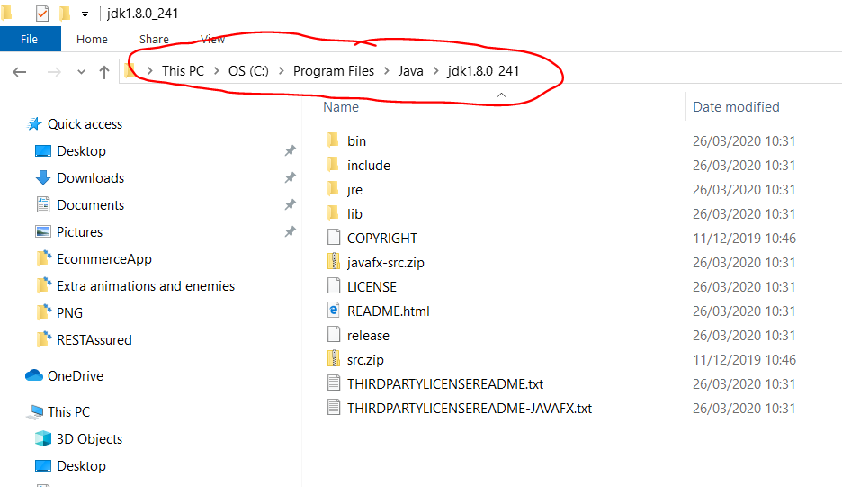

Also, add this to the path environment variable:-

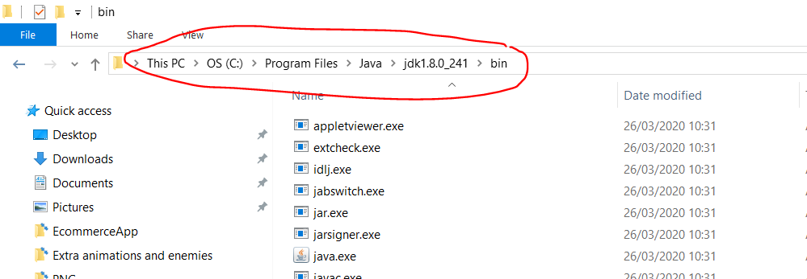

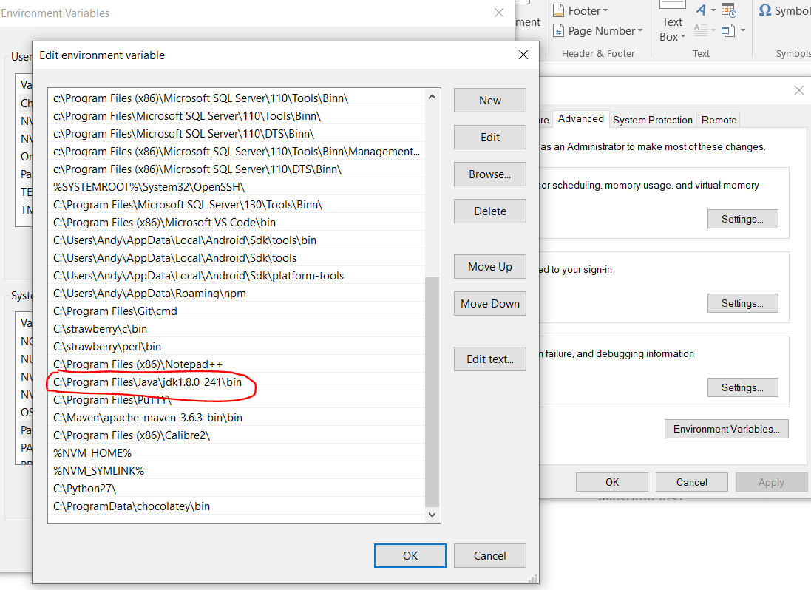

Download and install Eclipse.

Add RESTAssured jar files from here:-

<https://github.com/rest-assured/rest-assured/wiki/Downloads>

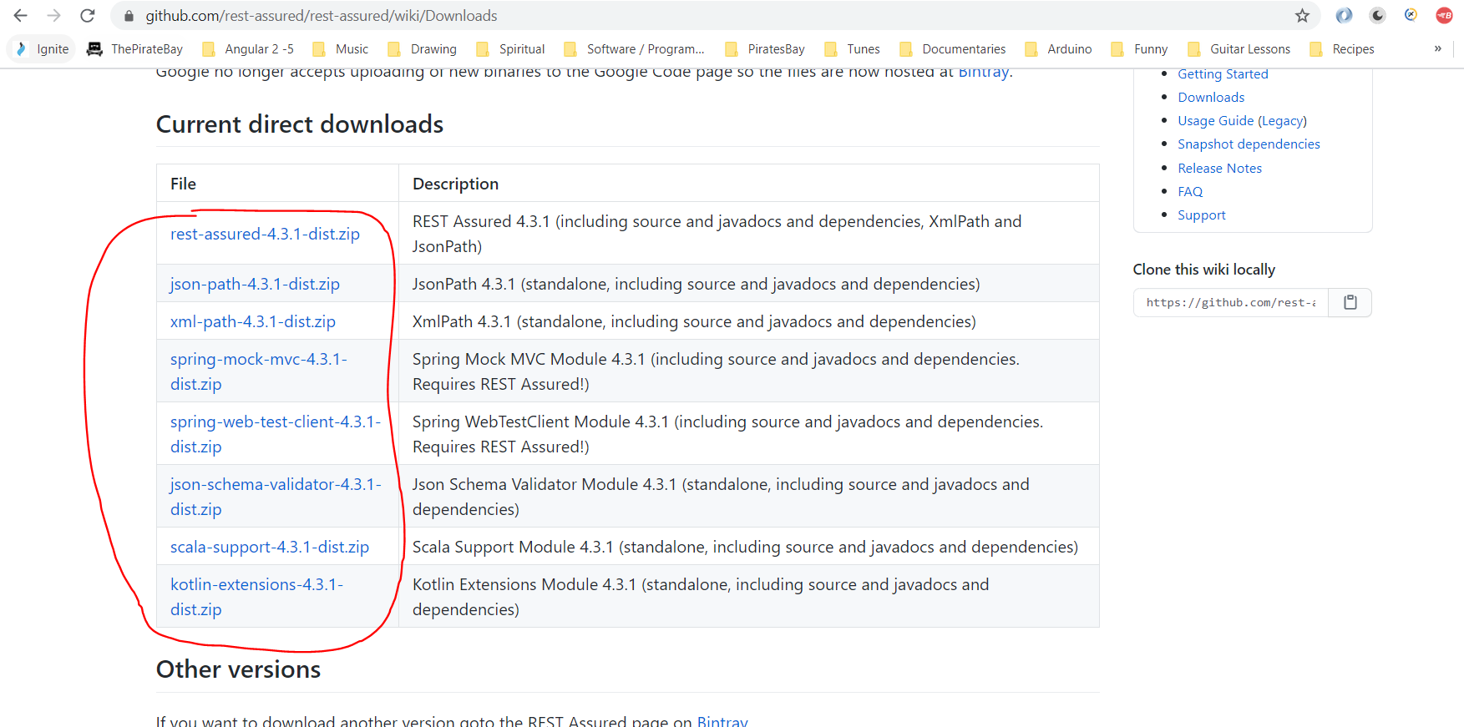

Unzip all the downloaded zip files.

In Eclipse create a new project:-

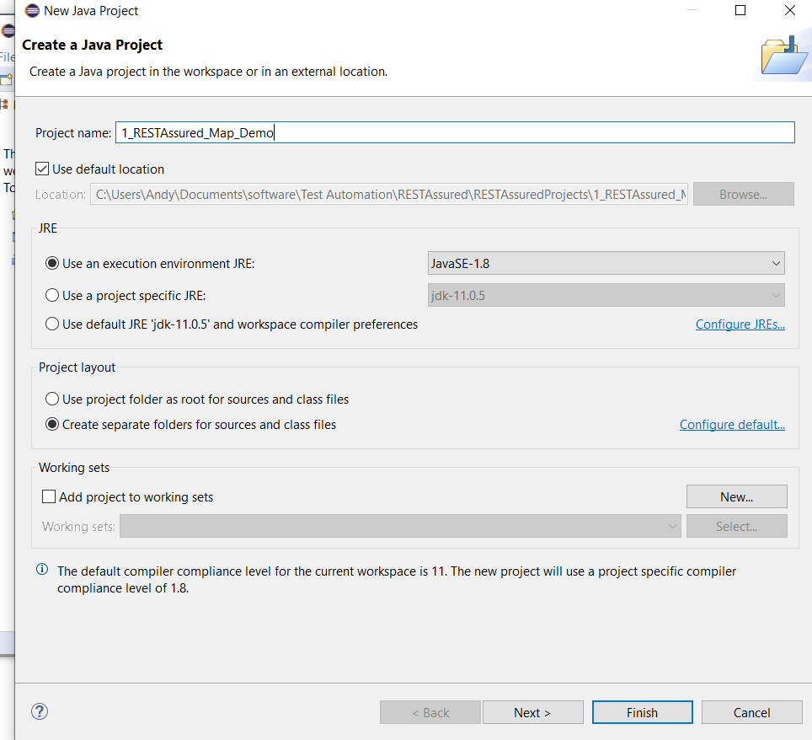

Right click the project and select ‘Properties’. Go to the following:-

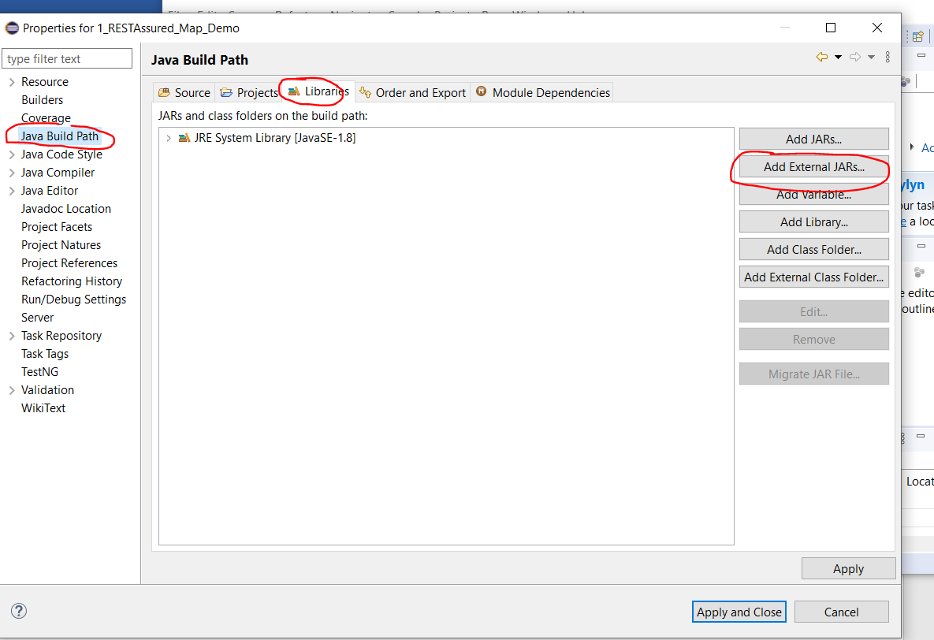

Click ‘Add External JARs’ and navigate to the unzipped downloaded JAR files:-

Note you will have to unzip zip files within zip files and import all jar fiels in all folders.

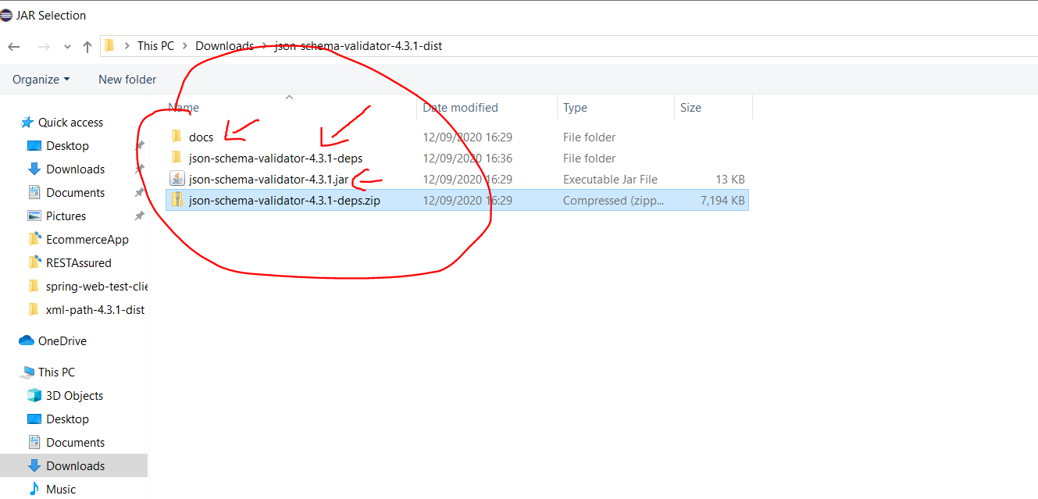

Then create a new class that does what you did in the Postman script:-

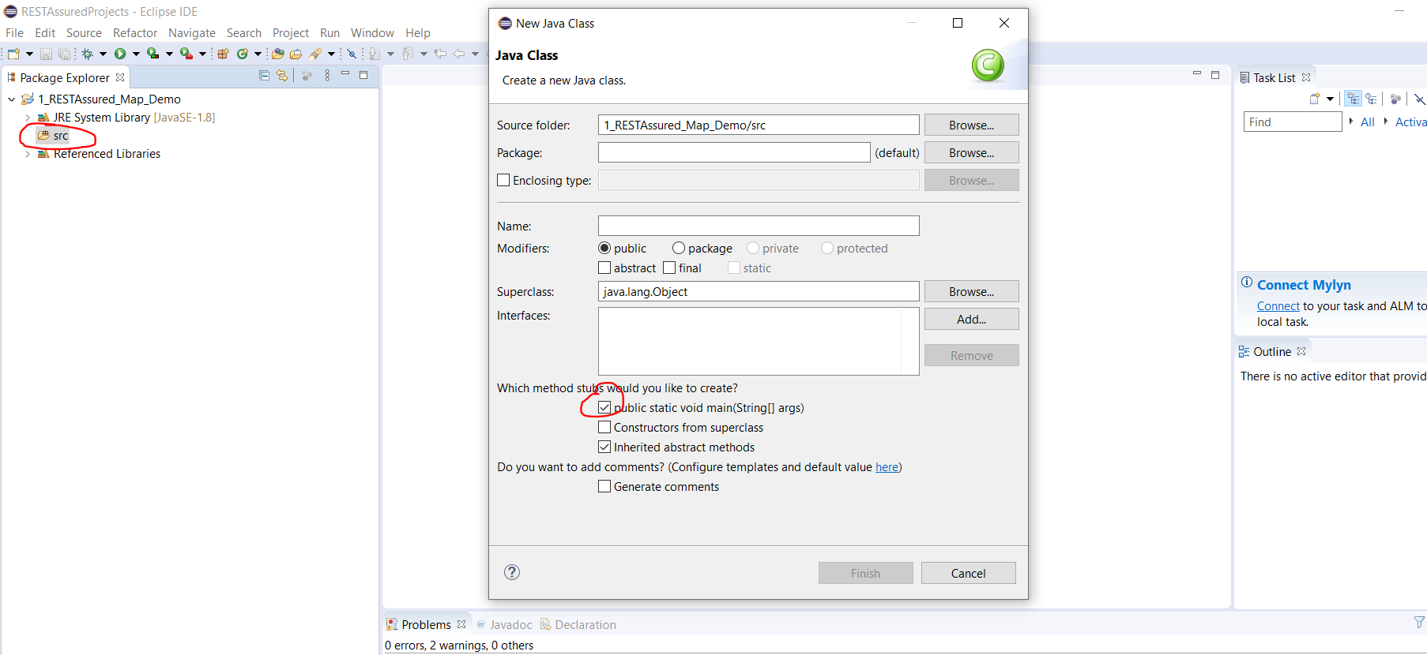

Add the following code to your class:-

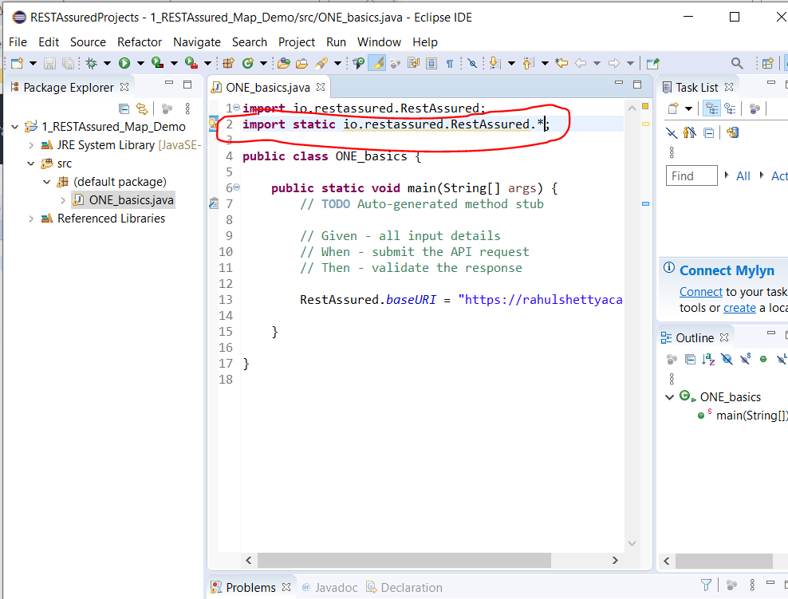

You will need to manually the above highlighted line.

To add the query parameters (like in Postman – see screen shot below):-

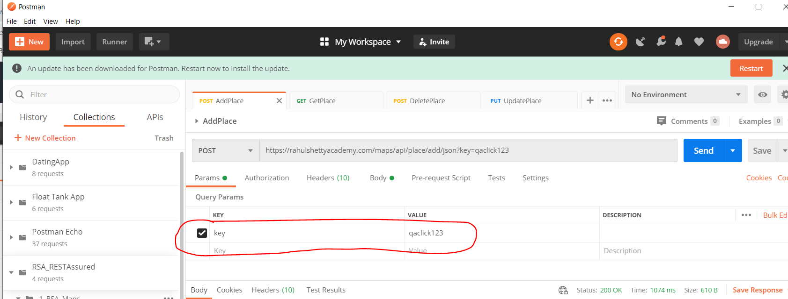

So add this to the code class:-

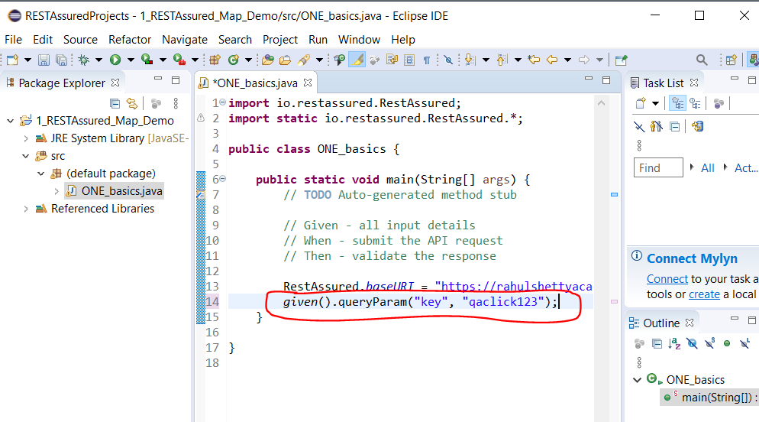

Add header info now (see Postman section below):-

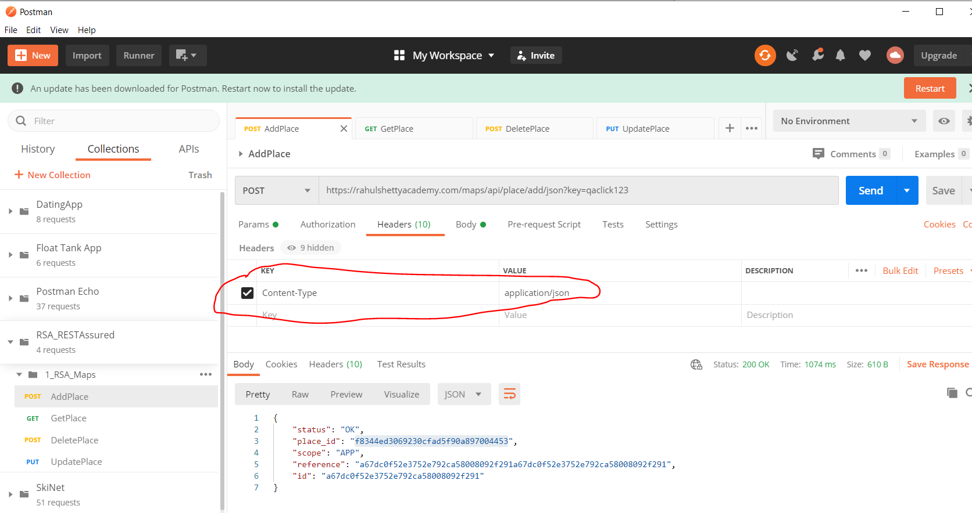

Add this the code:-

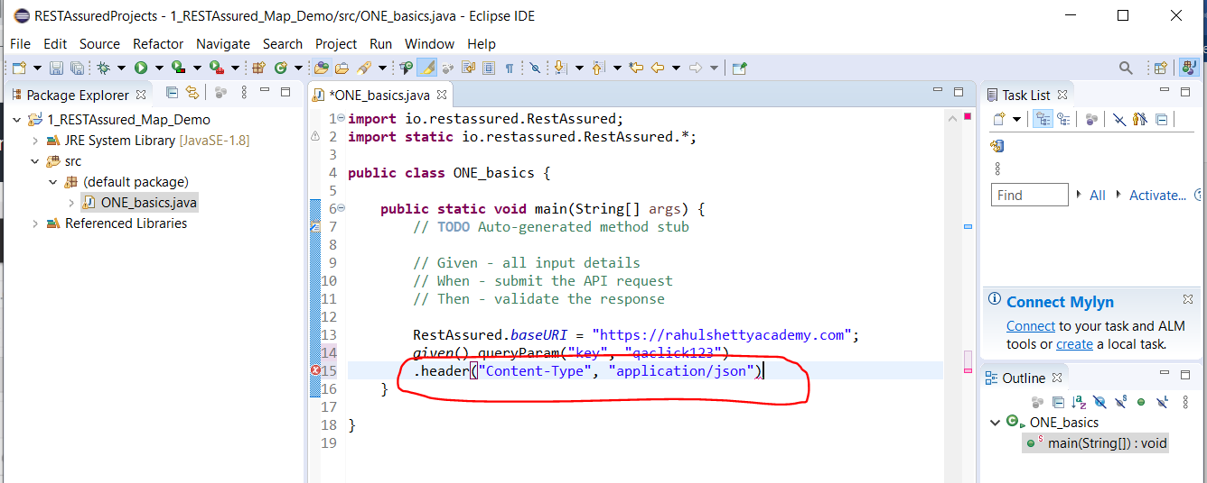

Now add the body section (see body section in Postman):-

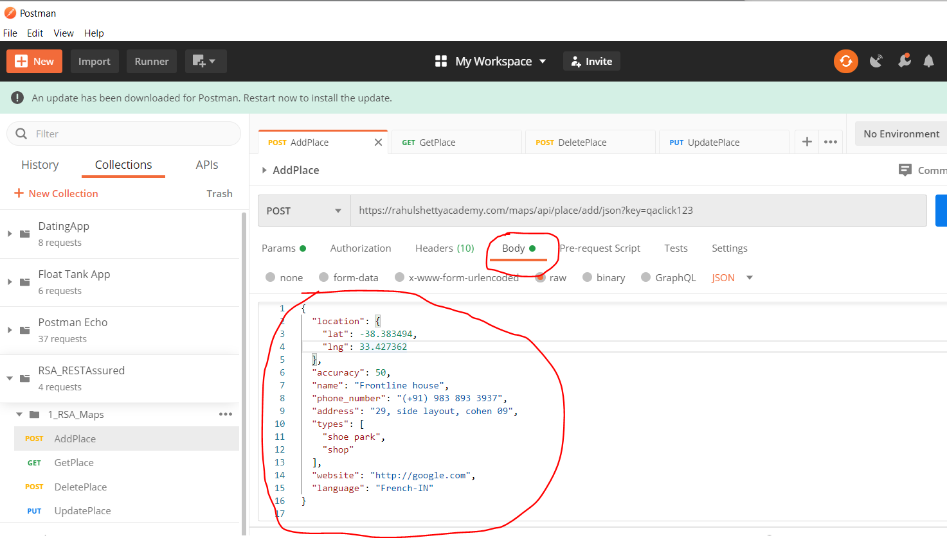

Add this code to the class:-

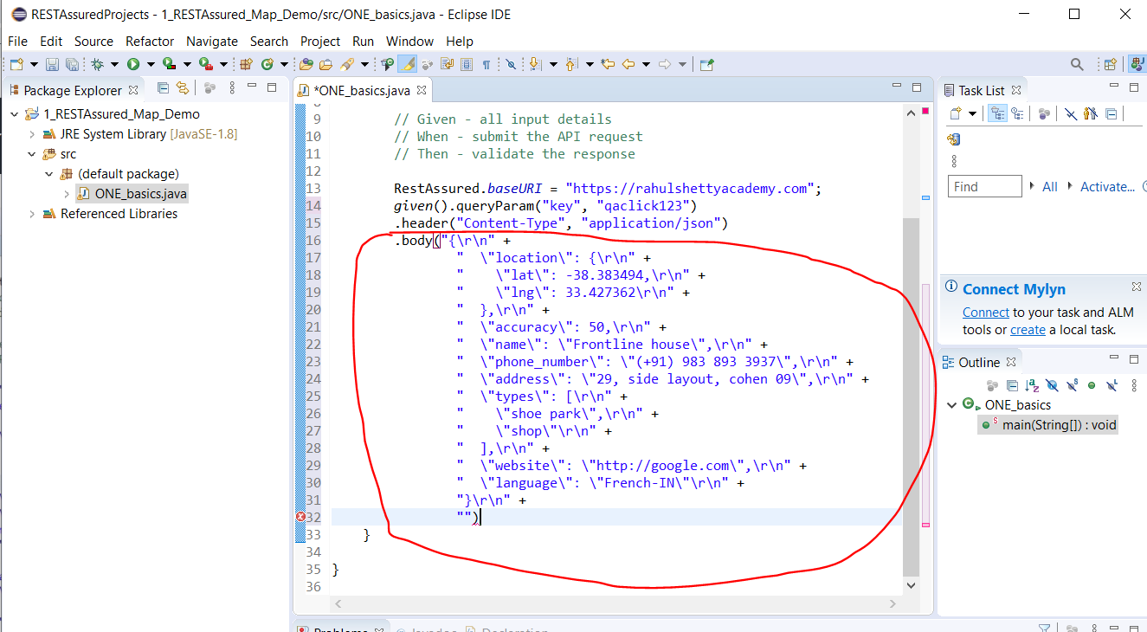

To make sure when copying the payload from the body section in Postman and pasting into Eclipse and it appears above you will need to ensure the following setting is set:-

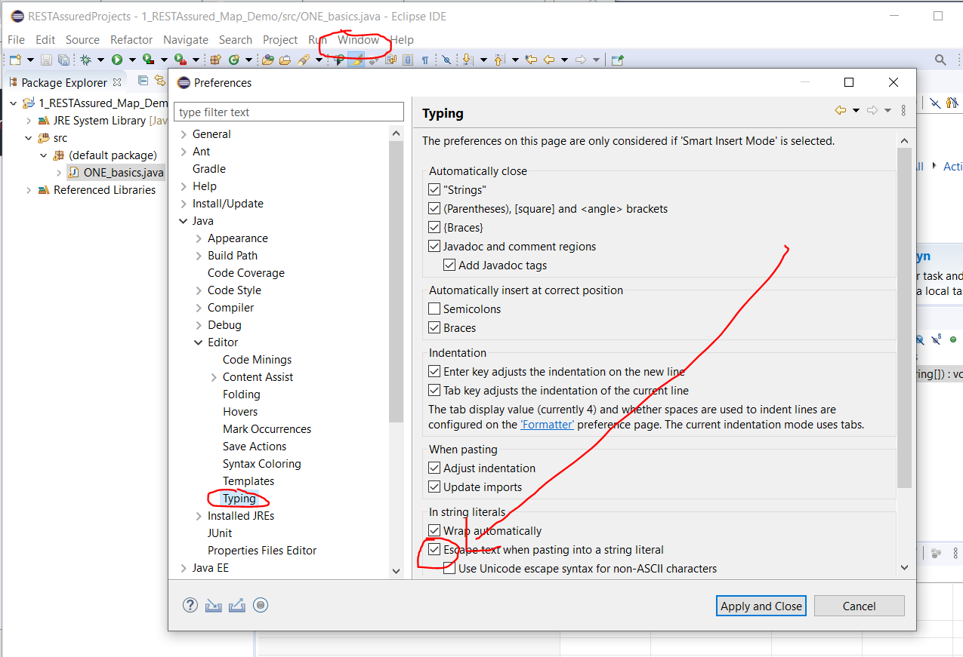

Then add the HTTP method type part to the code (see section in Postman below):-

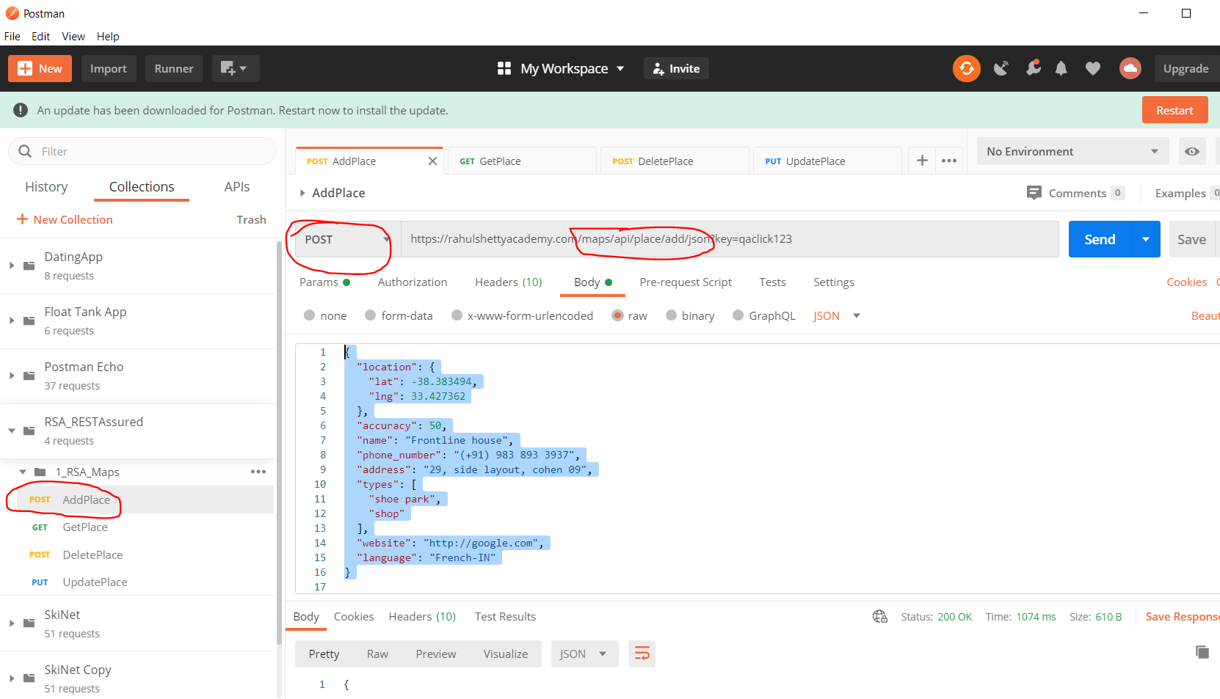

See code here:-

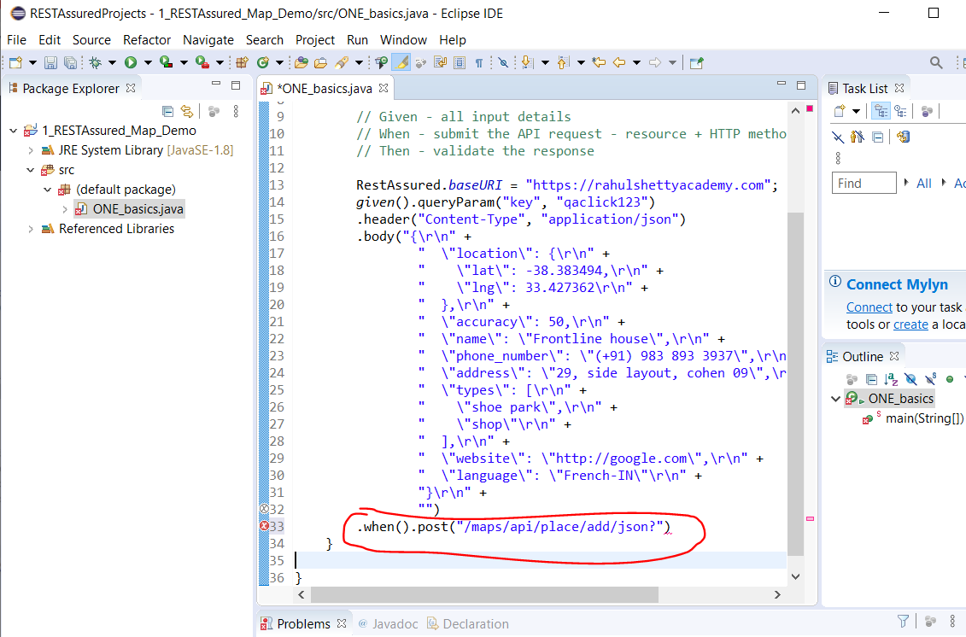

Now add code to validate the response:-

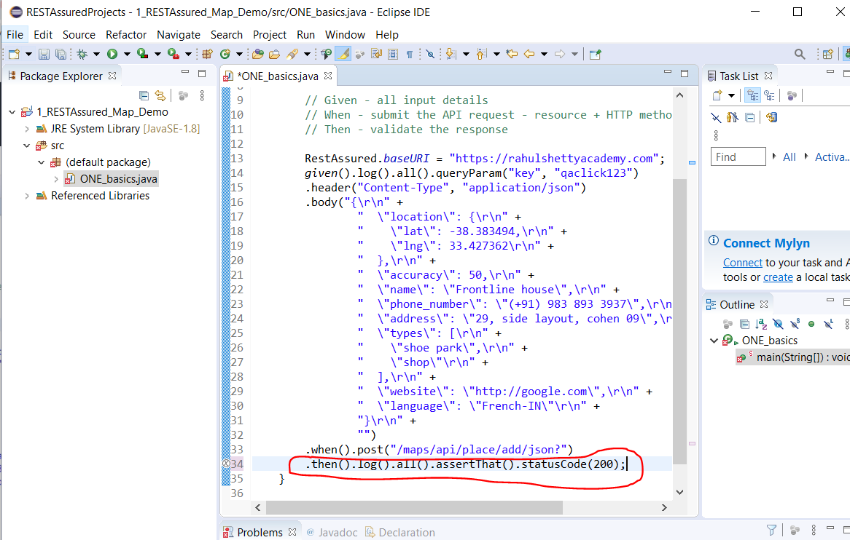

Validate the body of response too. For example assert that the body of the response contains this part:-

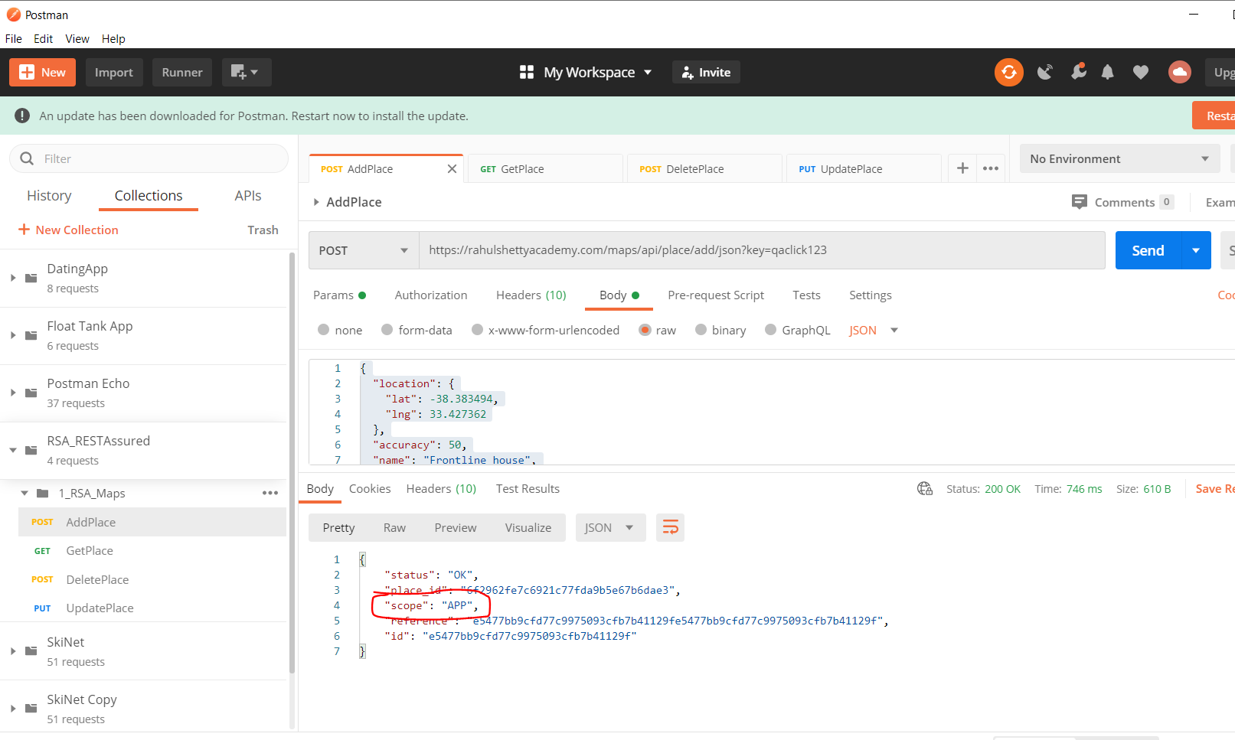

First import this package:-

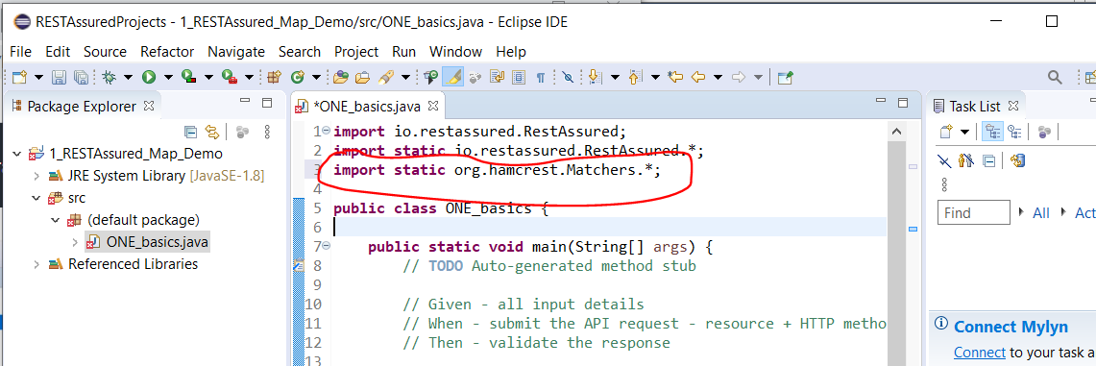

Add this assertion:-

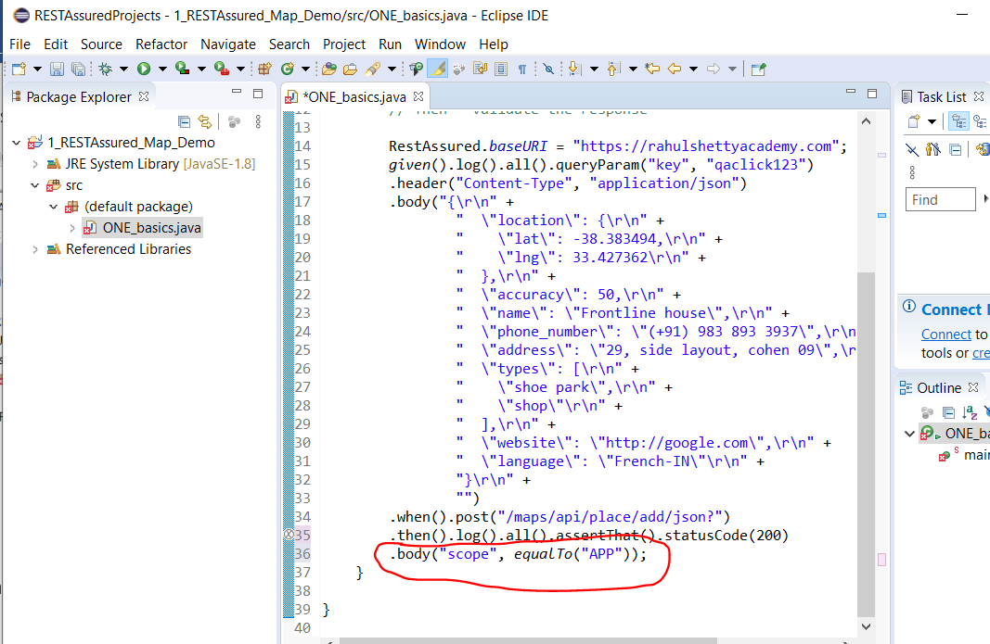

Also, click on the response ‘Header’ tab in Postman and assert that the server is Apache:-

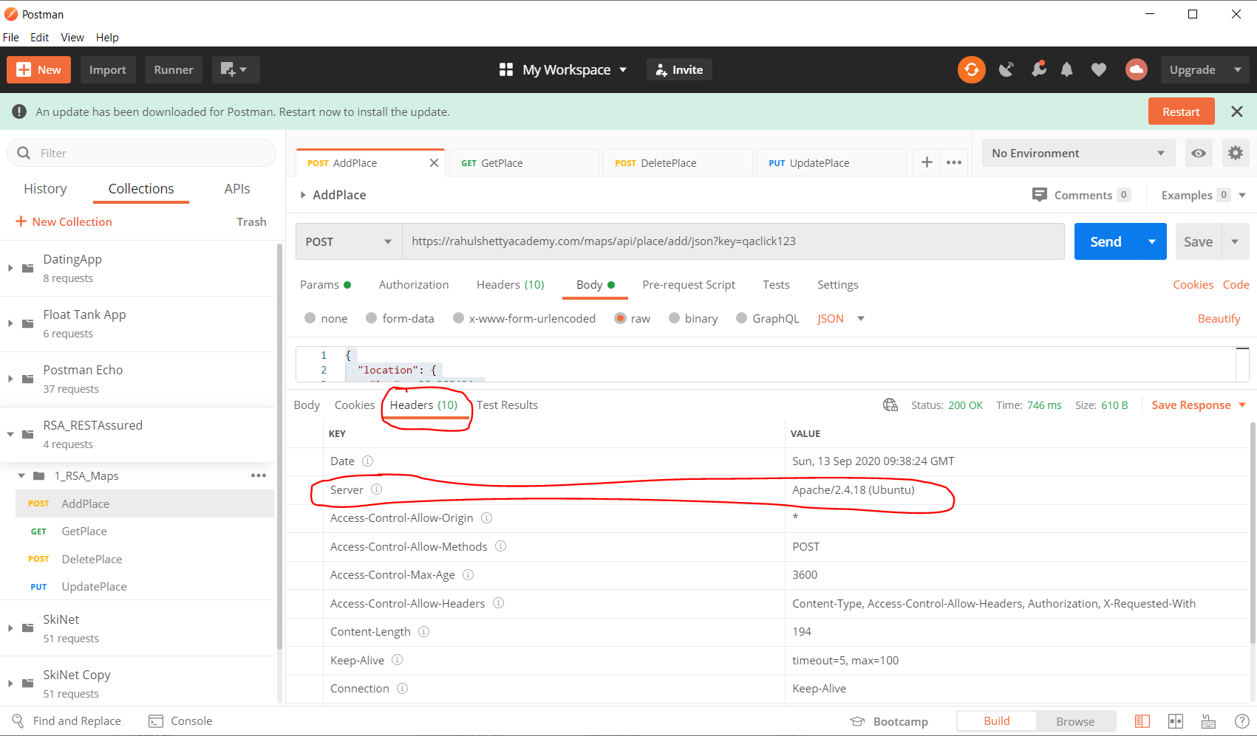

Write this code in eclipse:-

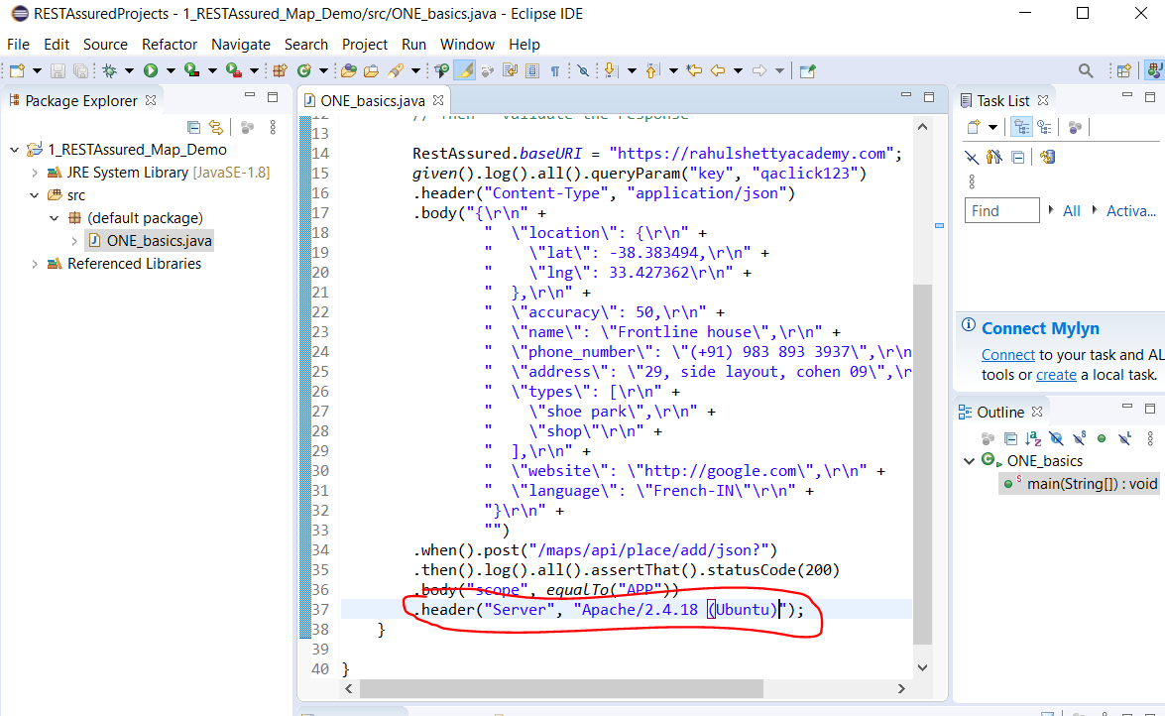

To tidy up the request body section (see screen shot showing the area I am talking about) this section can be taken out and put in a separate package:-

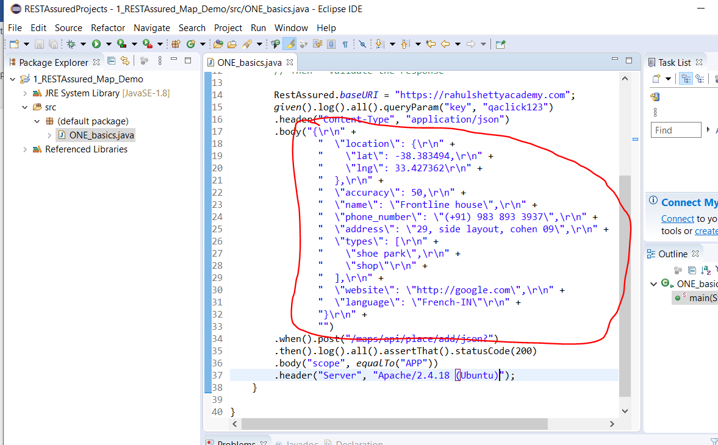

Create a new package:-

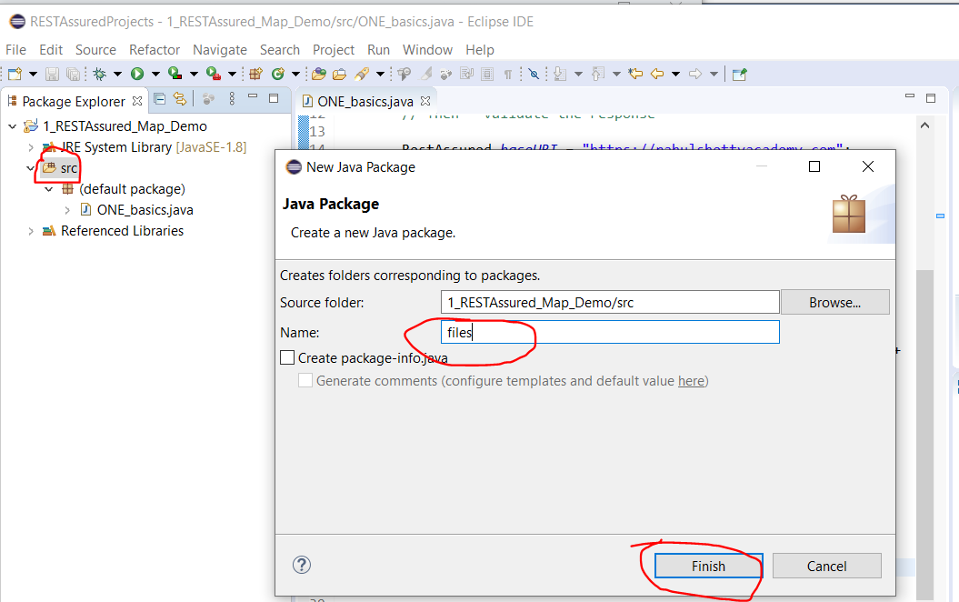

Then create a new static class:-

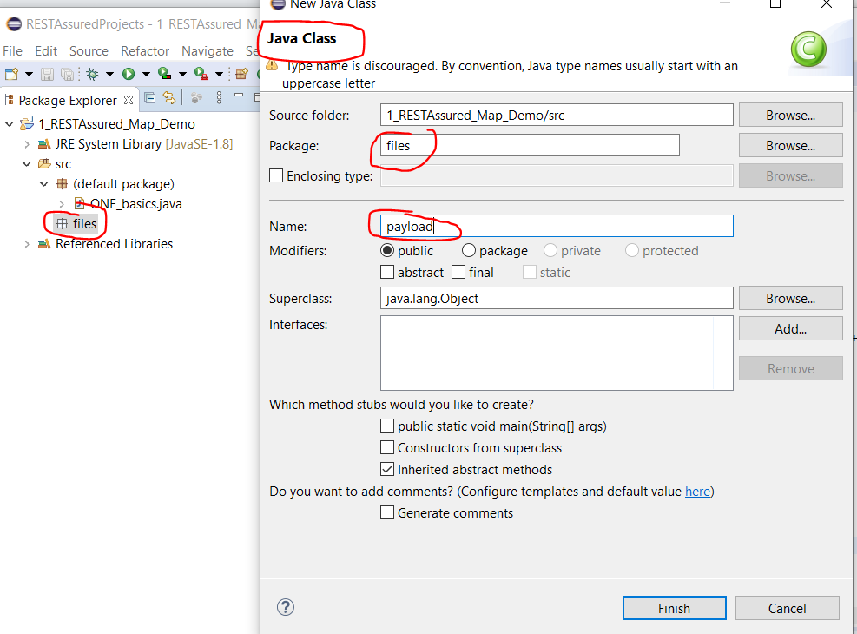

Add this code (Note:- copy the request body from Postman again):-

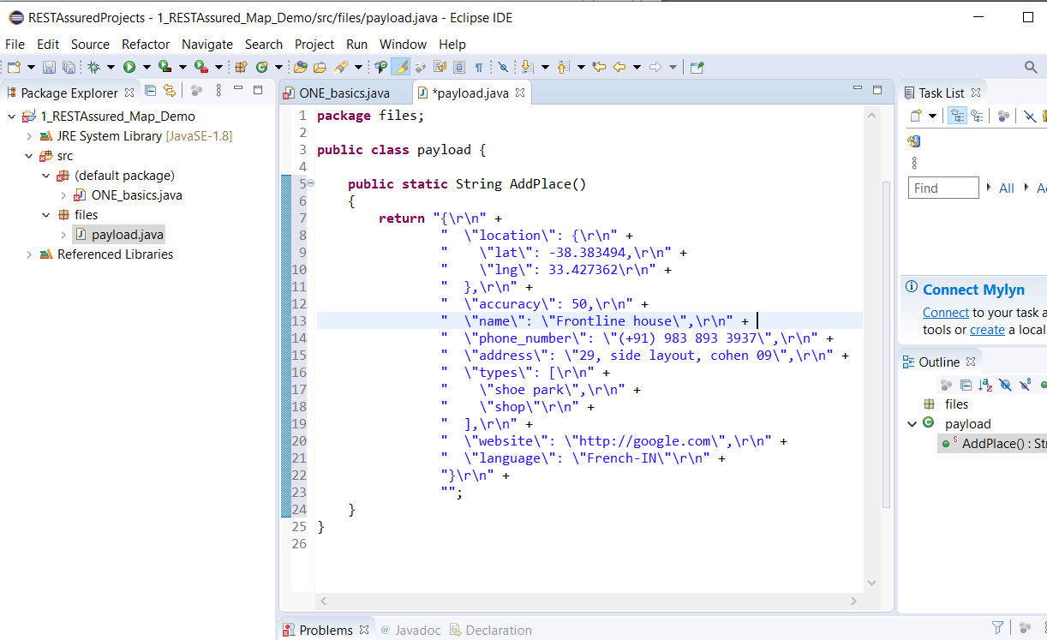

Then update the other class to reference the above class:-

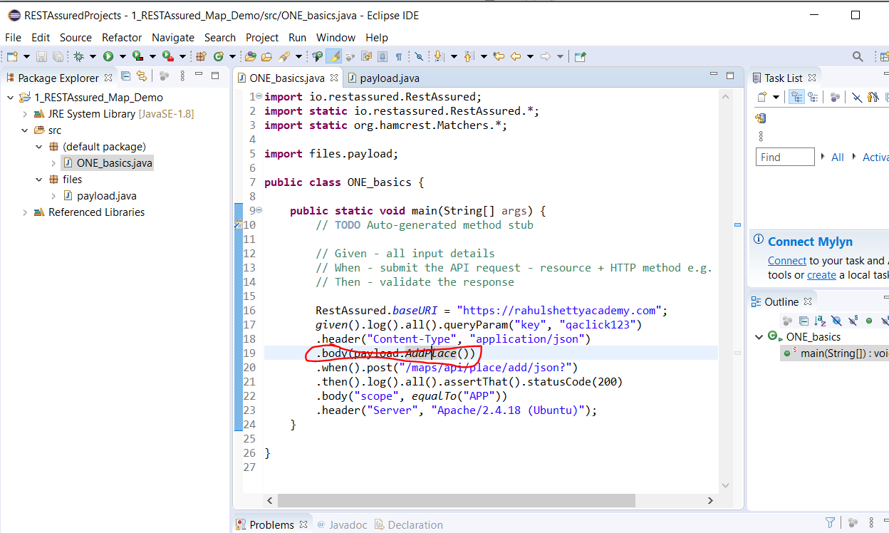

Now, edit the test class and extract the response. See below:-

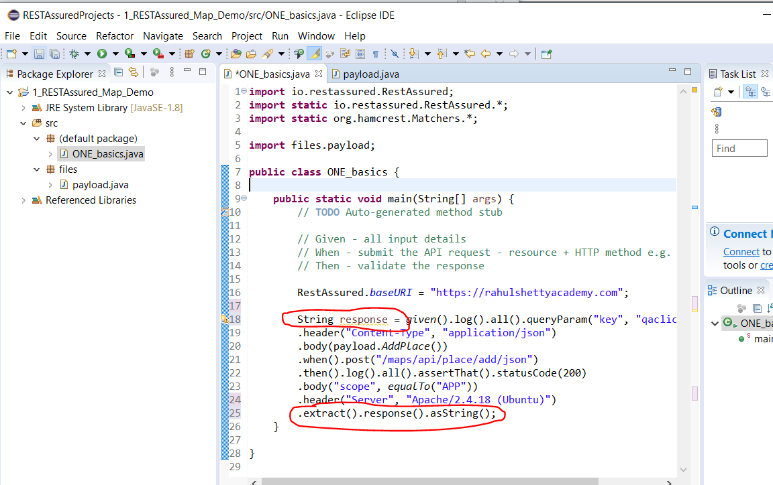

Now, parse the response returned in the String using the ‘JsonPath’ class. See below:-

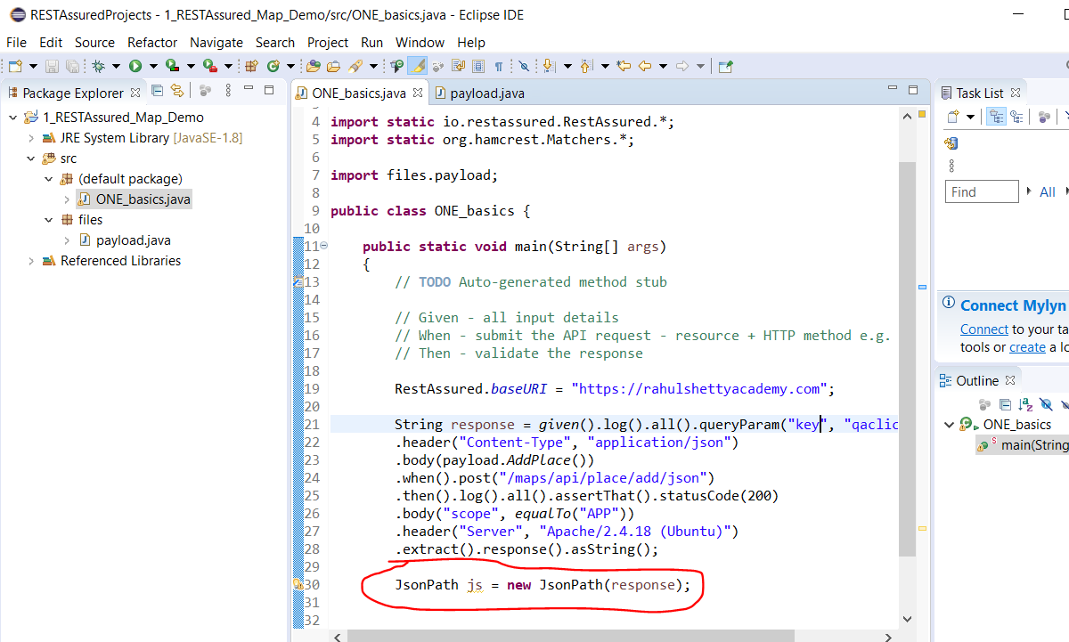

Then you can extract what ever part of the response object that you want, e.g. if you want to extract the ‘place_id’ do this:-

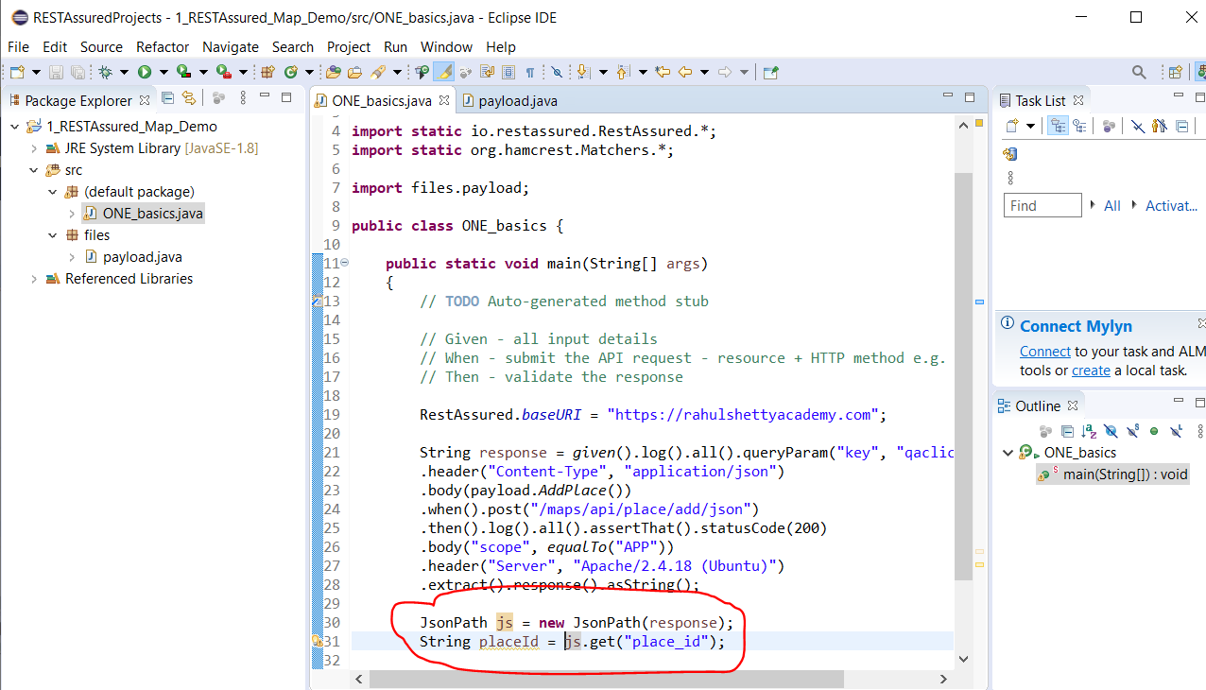

**Now add code for ‘Updating Place’**

First, copy the ‘UpdateMap’ body section from Postman:-

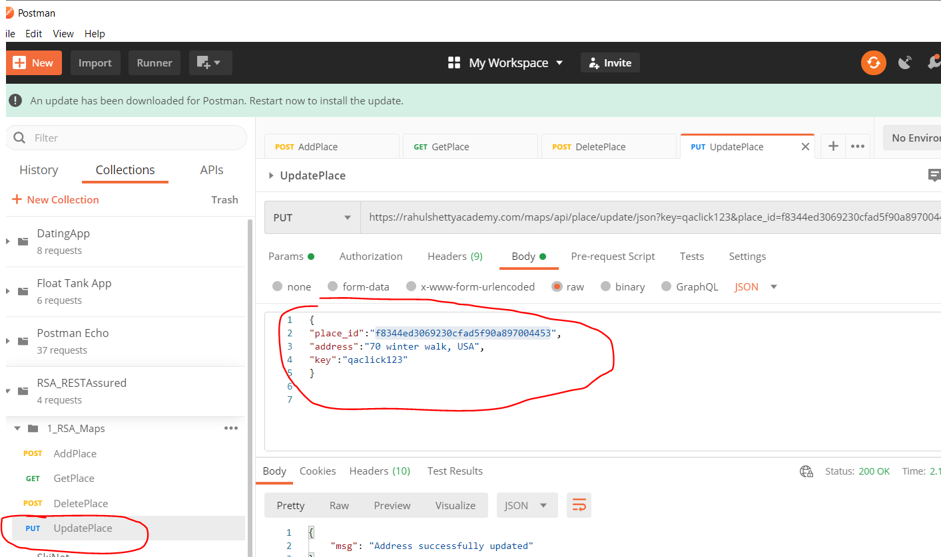

Add this code to the class:-

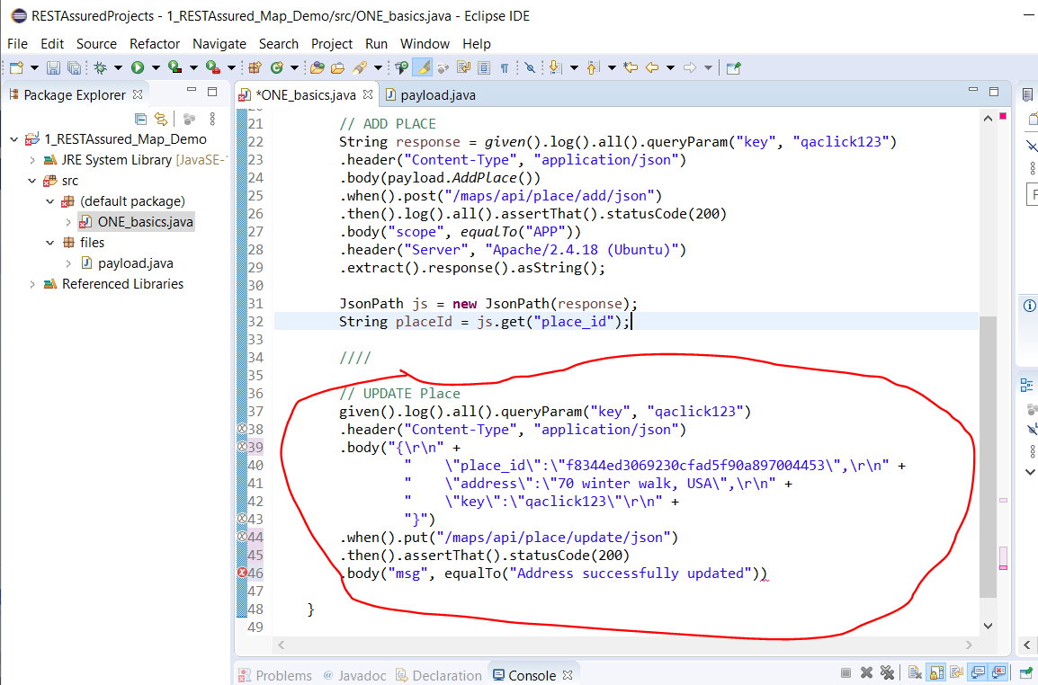

The problem with the above is that the body section is hardcoded therefore the ‘place_id’ is not dynamic therefore the test will fail. To overcome this do the following:-

Replace this section:-

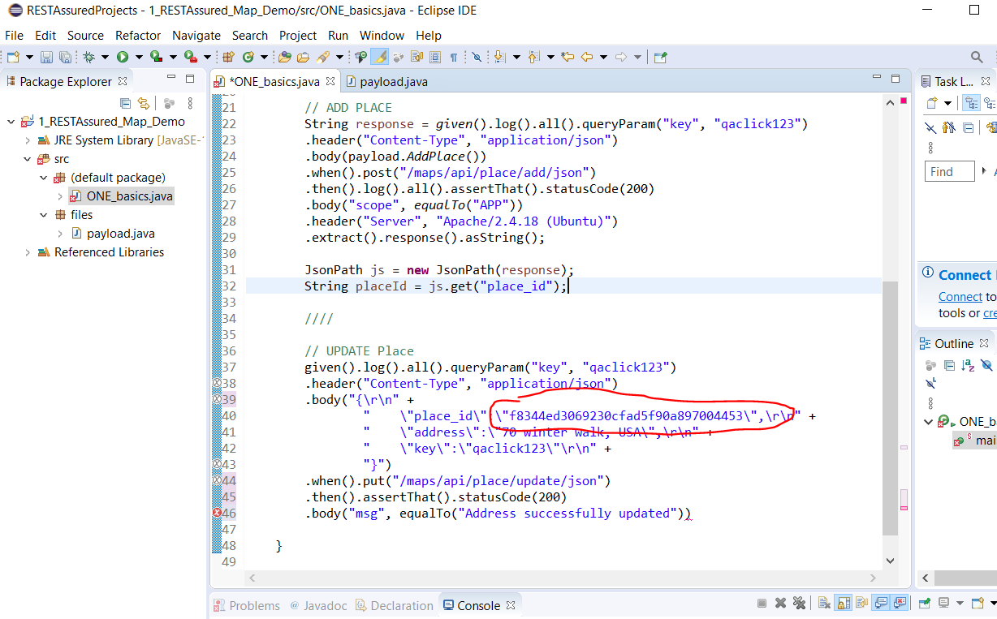

Replace with this:-

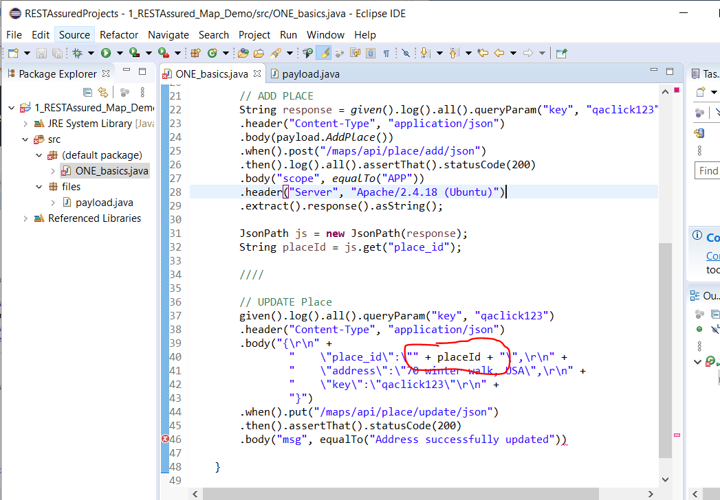

**Add code to test GET Place**

We need to set the ‘address’ first in the UPDATE place section of the test class. Then we would do an assertion compare between what has been returned from the GETPlace test and what we set in the UPDATE place test. See code below:-

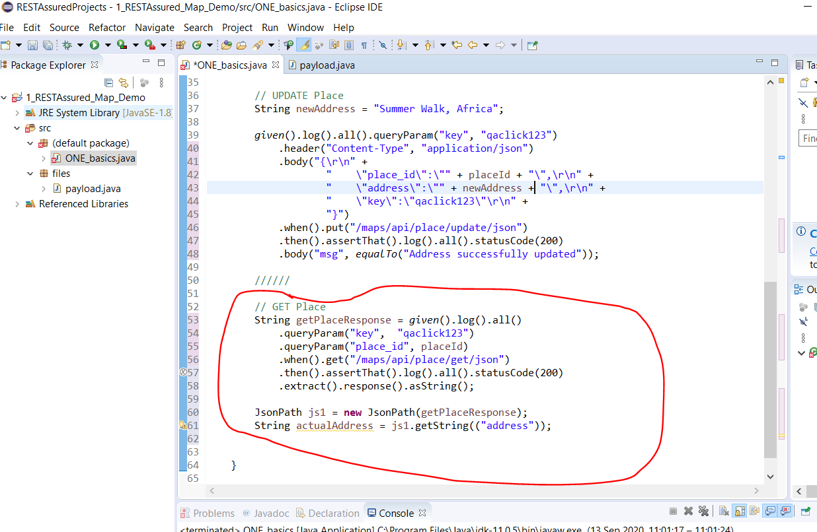

Now, add library for assertions – TestsNG. Add the following JARs to your project:-

<https://repo1.maven.org/maven2/org/testng/testng/6.7/>

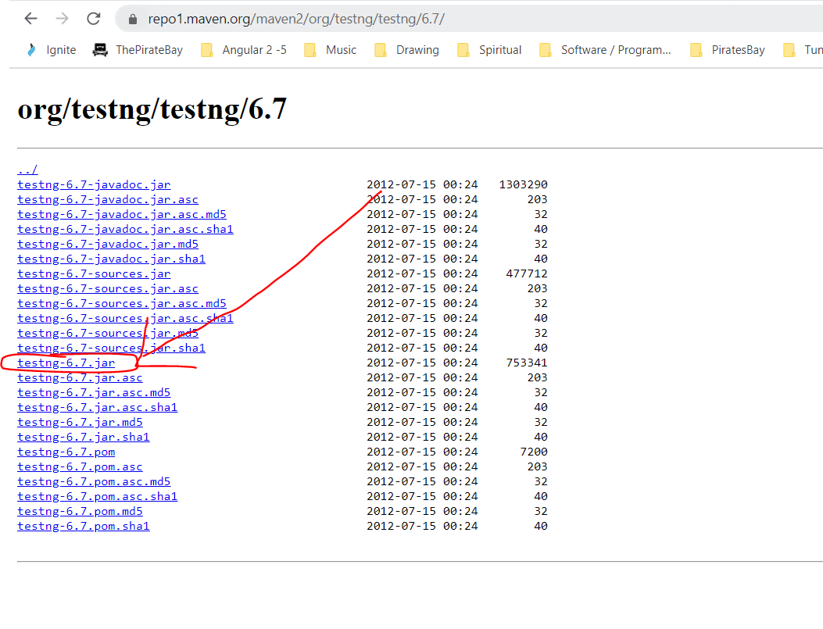

When downloaded add the external JAR to your project.

Now you can add this line of code to your test class to perform an assertion:-

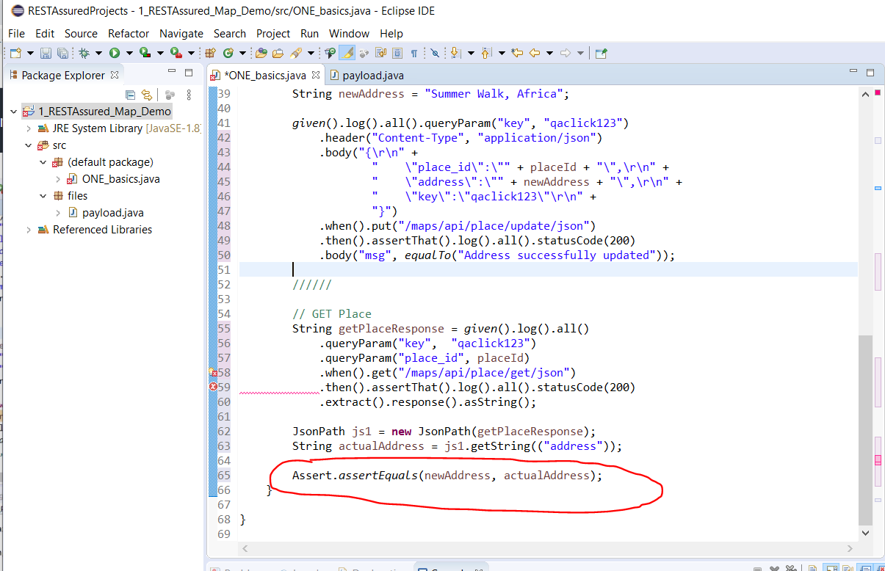

Tidy your code by creating a new ‘ResuableMethods’ class with common code in it:-

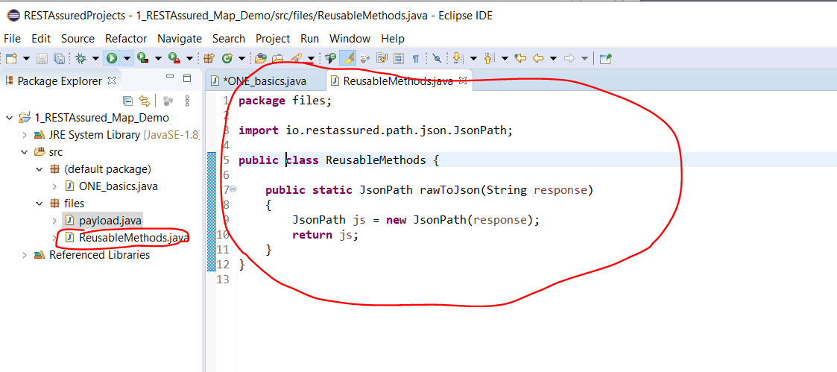

Change the UPDATE Place test to use the above class method:-

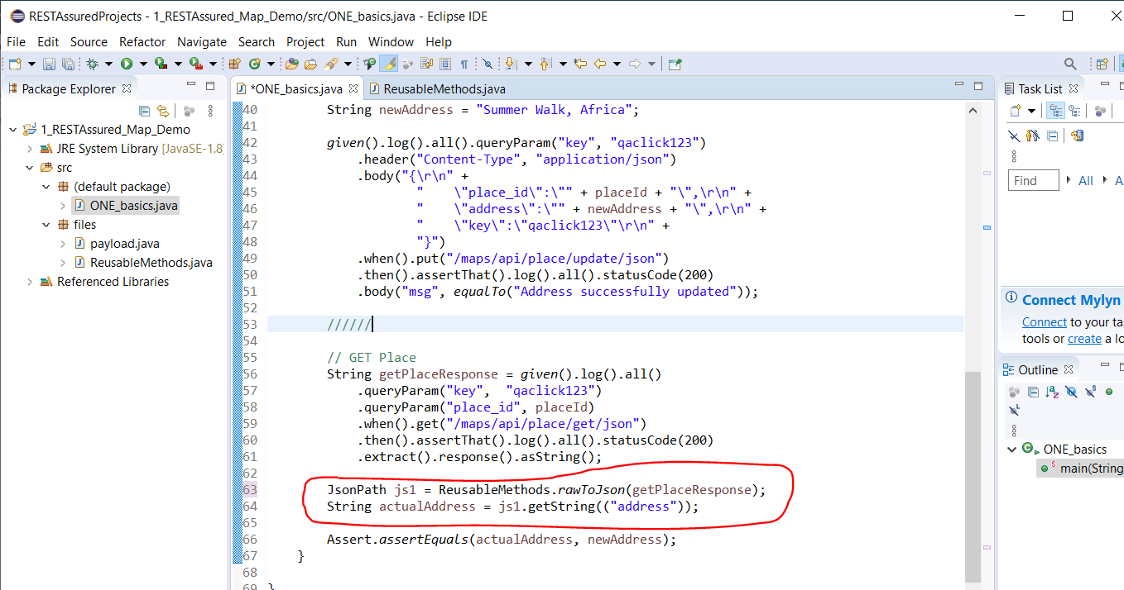

**Working with Complex JSON arrays**

For example see complex JSON below:-

{

"dashboard": {

"purchaseAmount": 910,

"website": "rahulshettyacademy.com"

},

"courses": [

{

"title": "Selenium Python",

"price": 50,

"copies": 6

},

{

"title": "Cypress",

"price": 40,

"copies": 4

},

{

"title": "RPA",

"price": 45,

"copies": 10

}

]

}

Paste above into this website:-

<https://jsoneditoronline.org/>

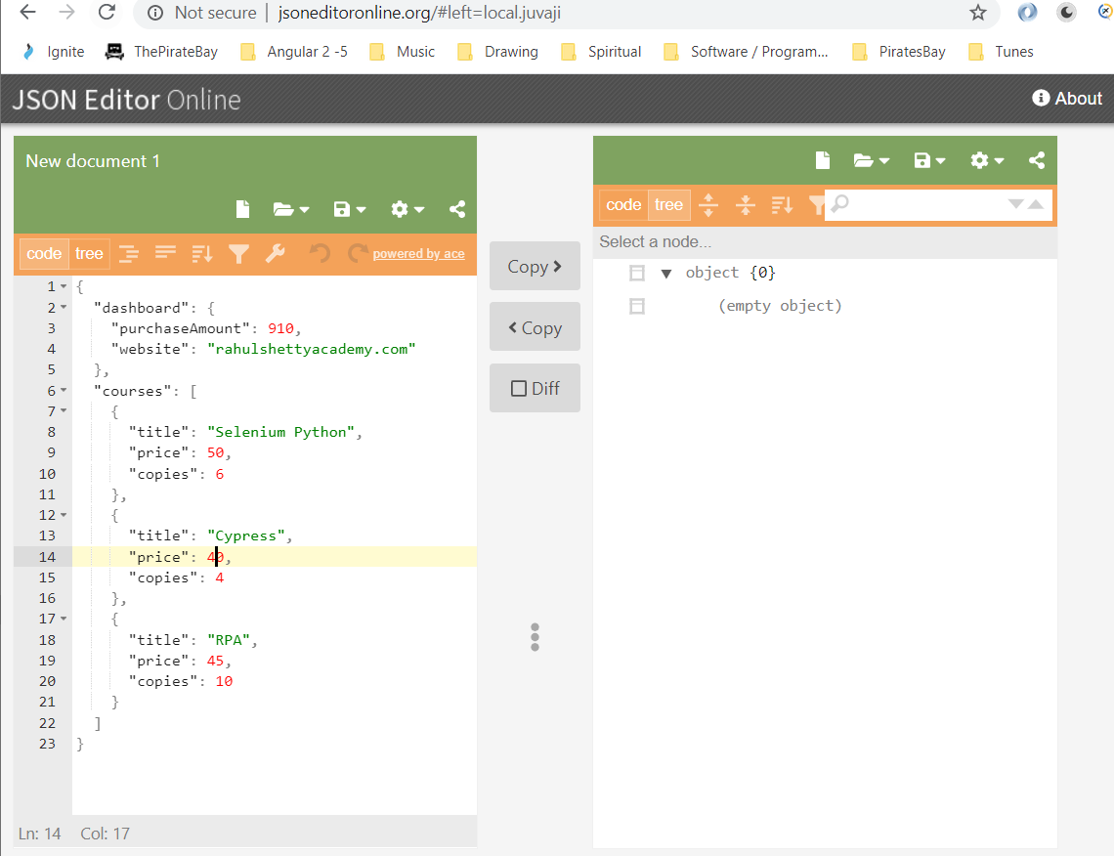

To print the number of courses returned by the API:-

You can see there are 3 courses:-

* Selenium Python
* Cypress
* RPA

See list of things to get below:-

1. Print No of courses returned by API

2.Print Purchase Amount

3. Print Title of the first course

4. Print All course titles and their respective Prices

5. Print no of copies sold by RPA Course

6. Verify if Sum of all Course prices matches with Purchase Amount

Square brackets [] mean that this is an array of objects:-

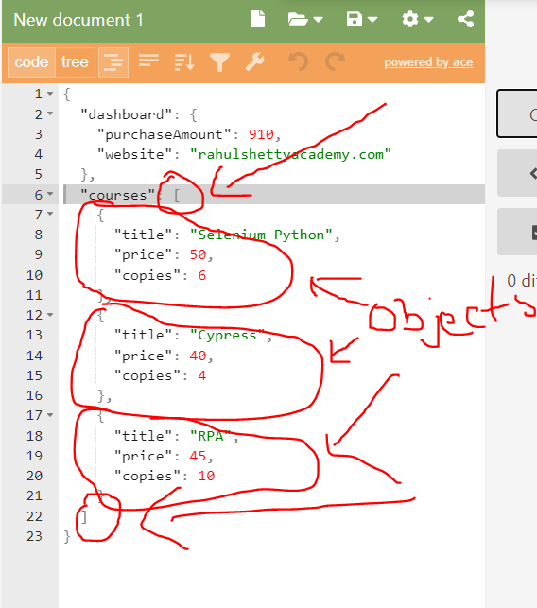

Create a new class for dealing with this Complex JSON Parsing:-

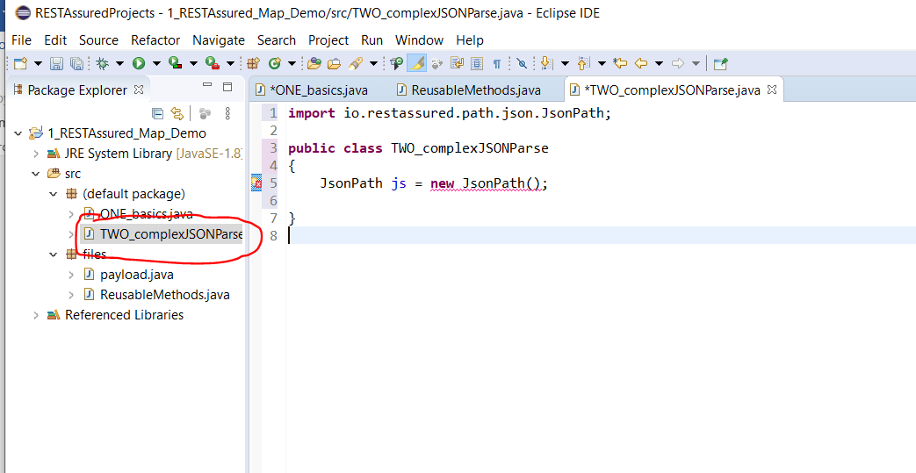

Create a new method in the payload class and copy the Course Price complex JSON object:-

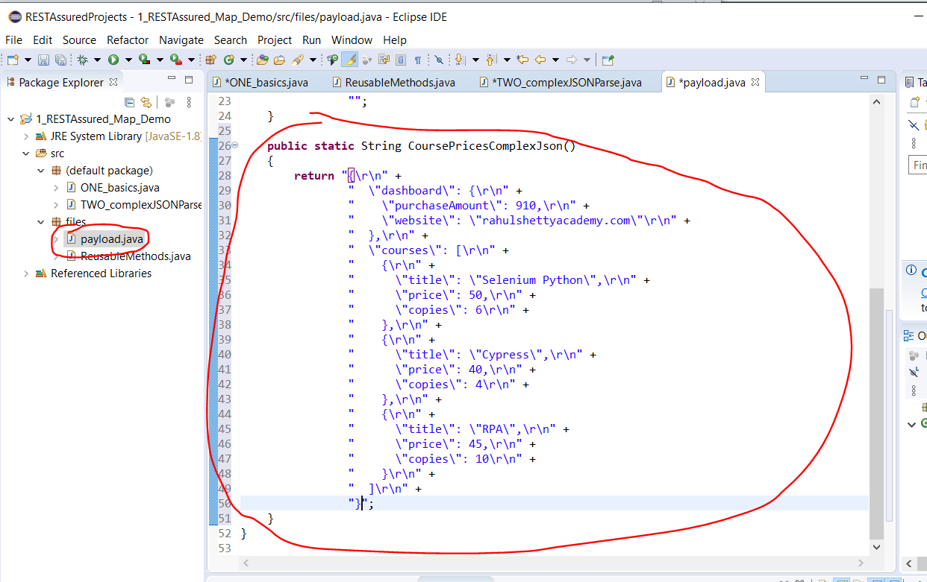

Now answer each of the above questions:-

1. Print No of courses returned by API

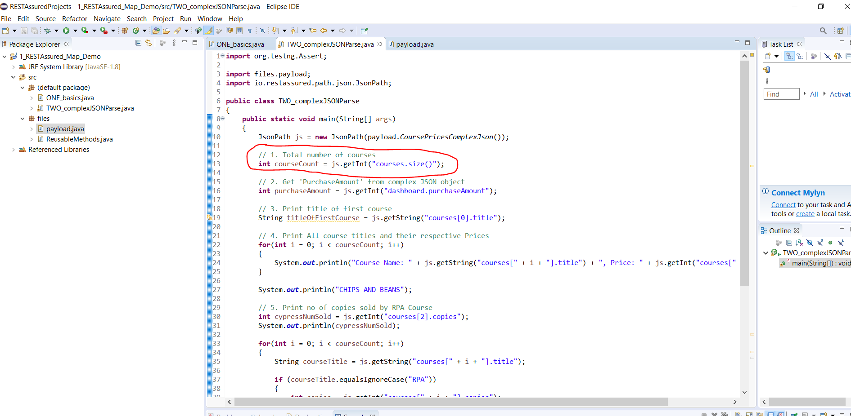

2.Print Purchase Amount

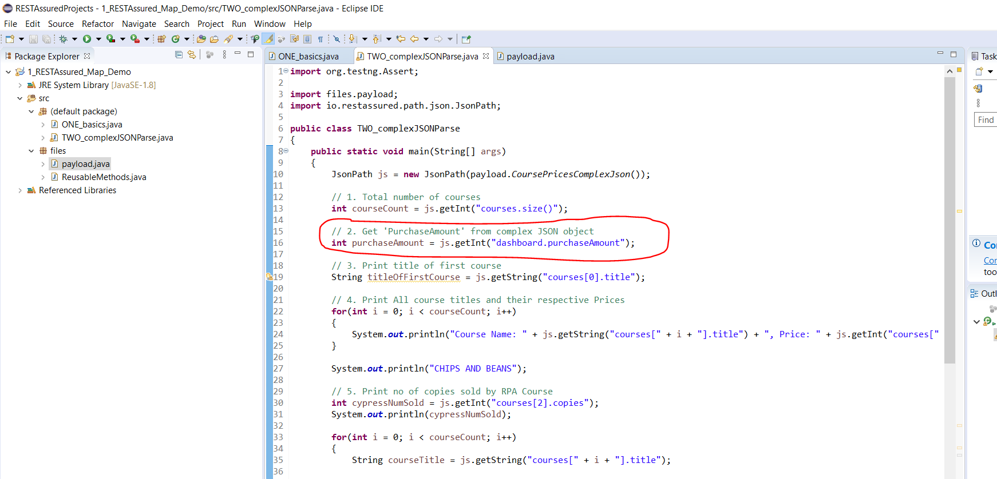

3. Print Title of the first course

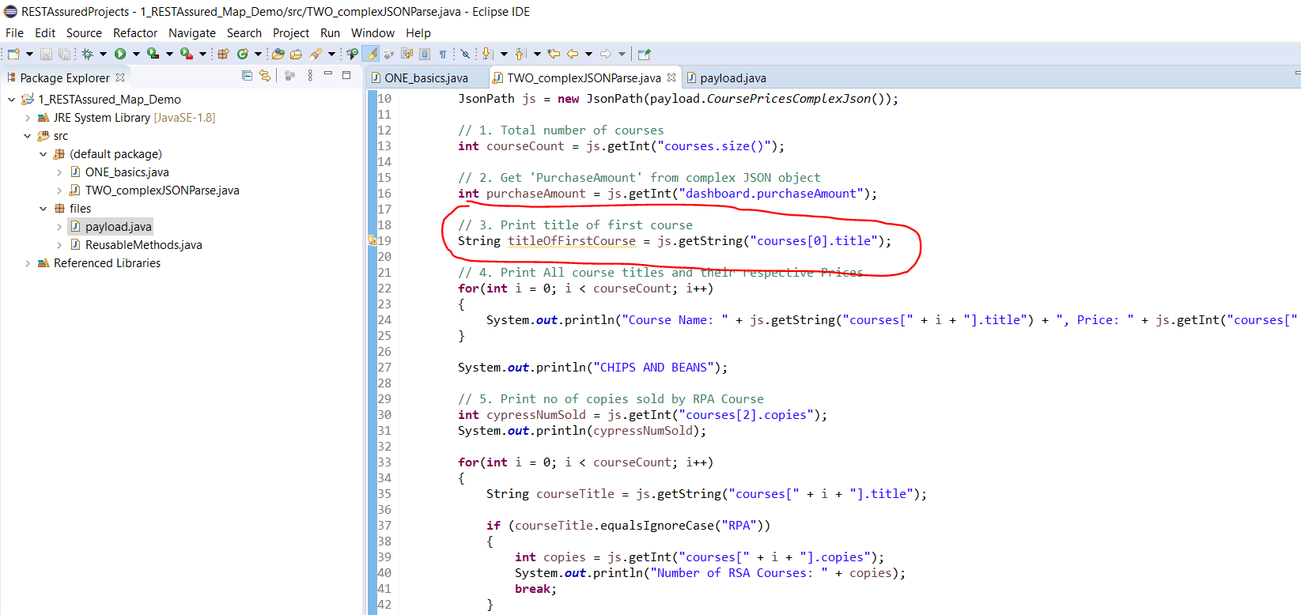

4. Print All course titles and their respective Prices

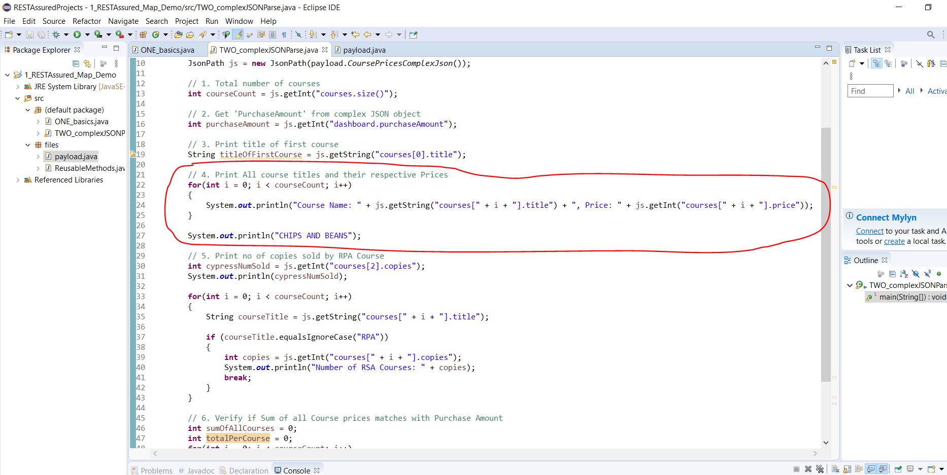

5. Print no of copies sold by RPA Course

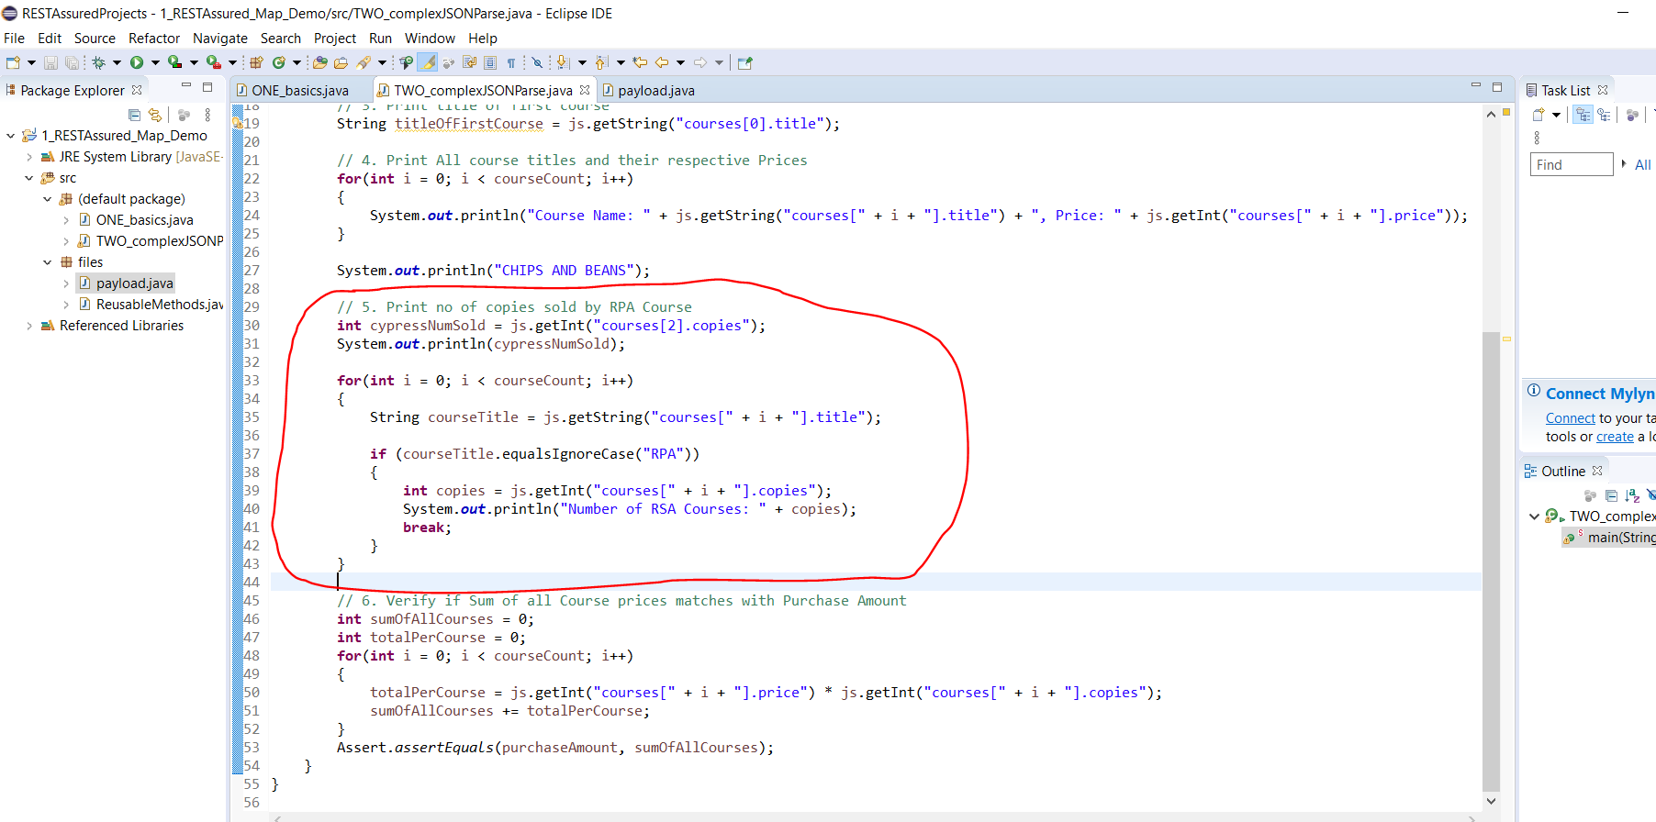

6. Verify if Sum of all Course prices matches with Purchase Amount

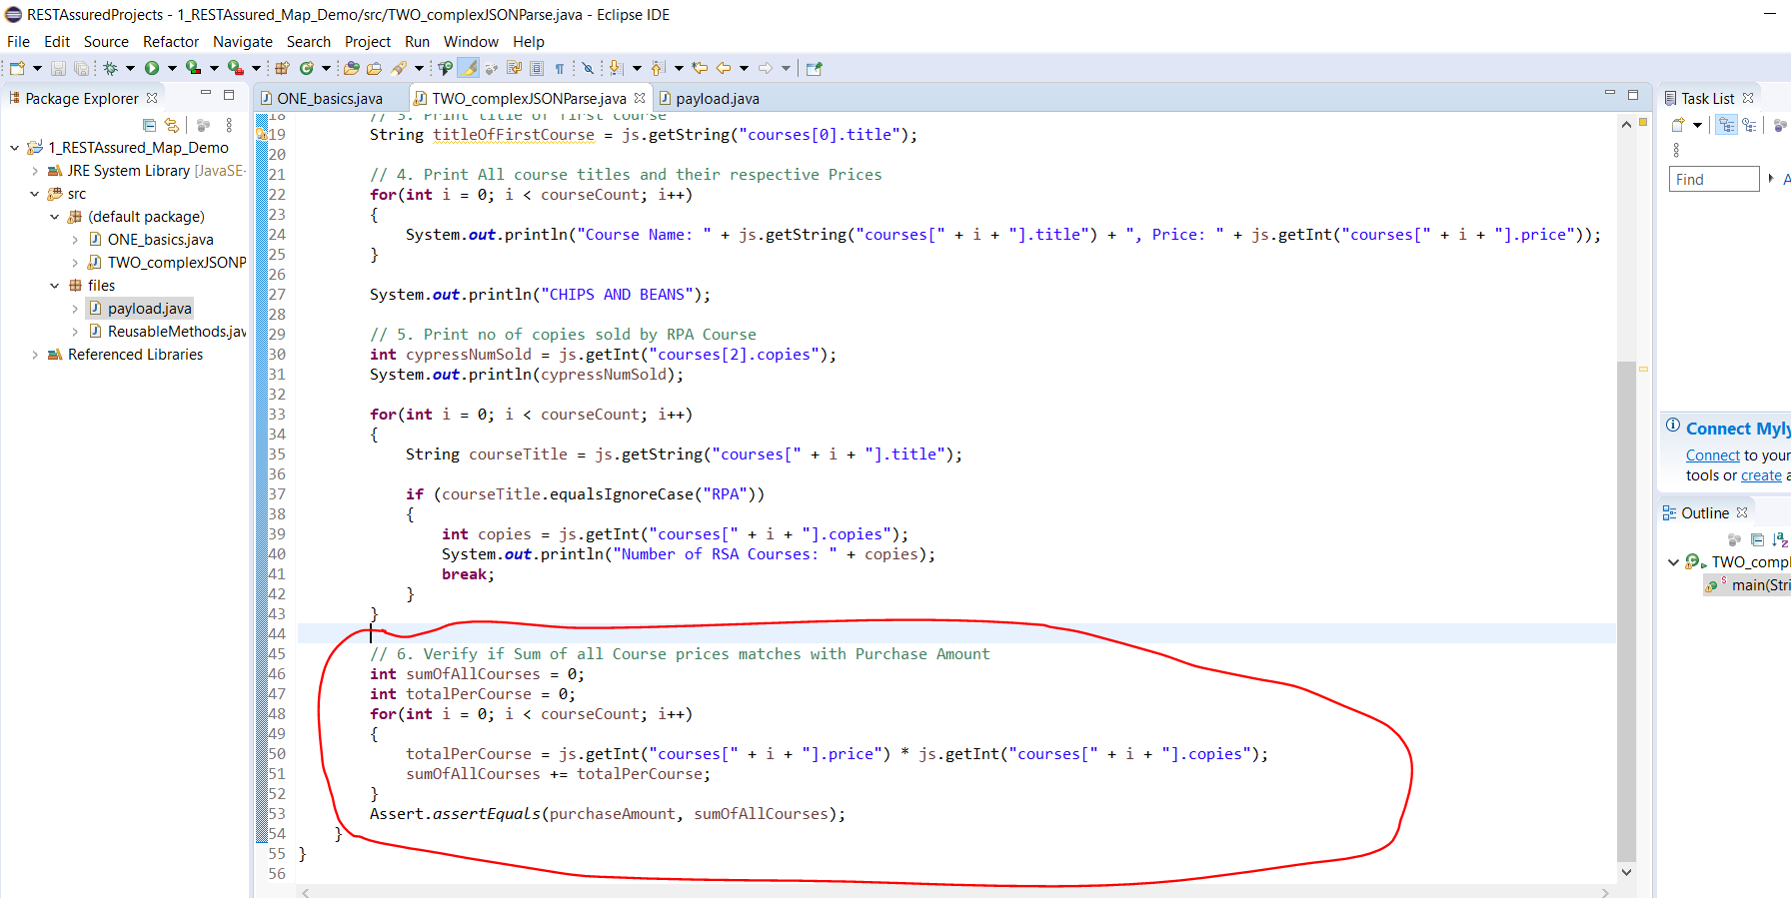

Now create a new class just to test the above last step and to use TestNG instead:-

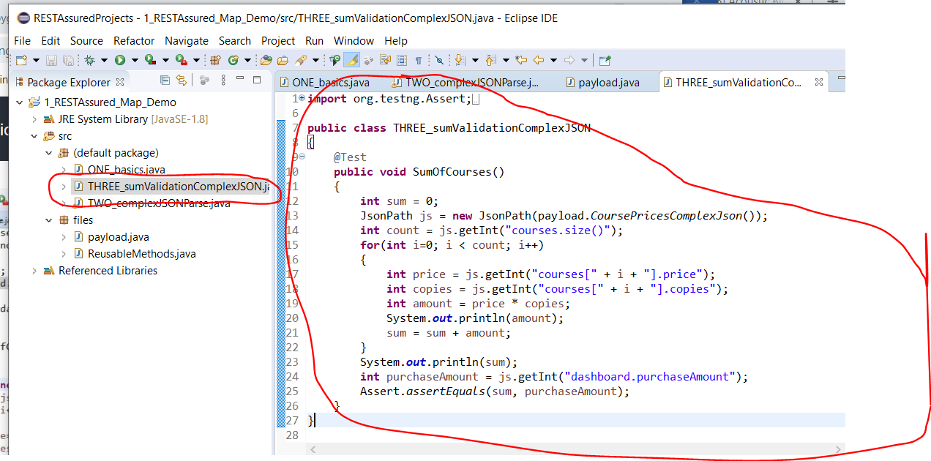

Try to run the class by right clicking anywhere in the class and selecting ‘Run As -> TestNG Test’. You will see this error in the console:-

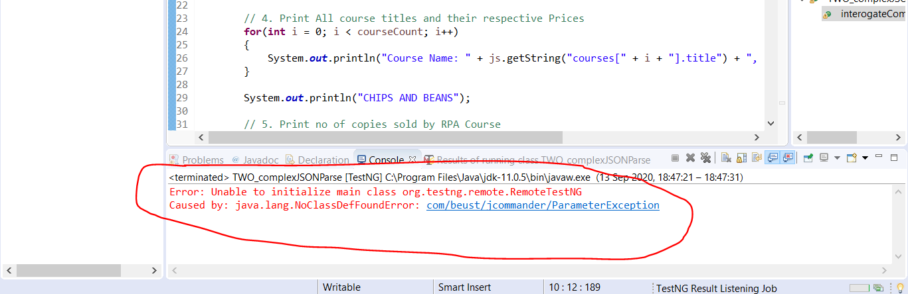

To get rid of this error you need to add this library:-

<https://mvnrepository.com/artifact/com.beust/jcommander/1.78>

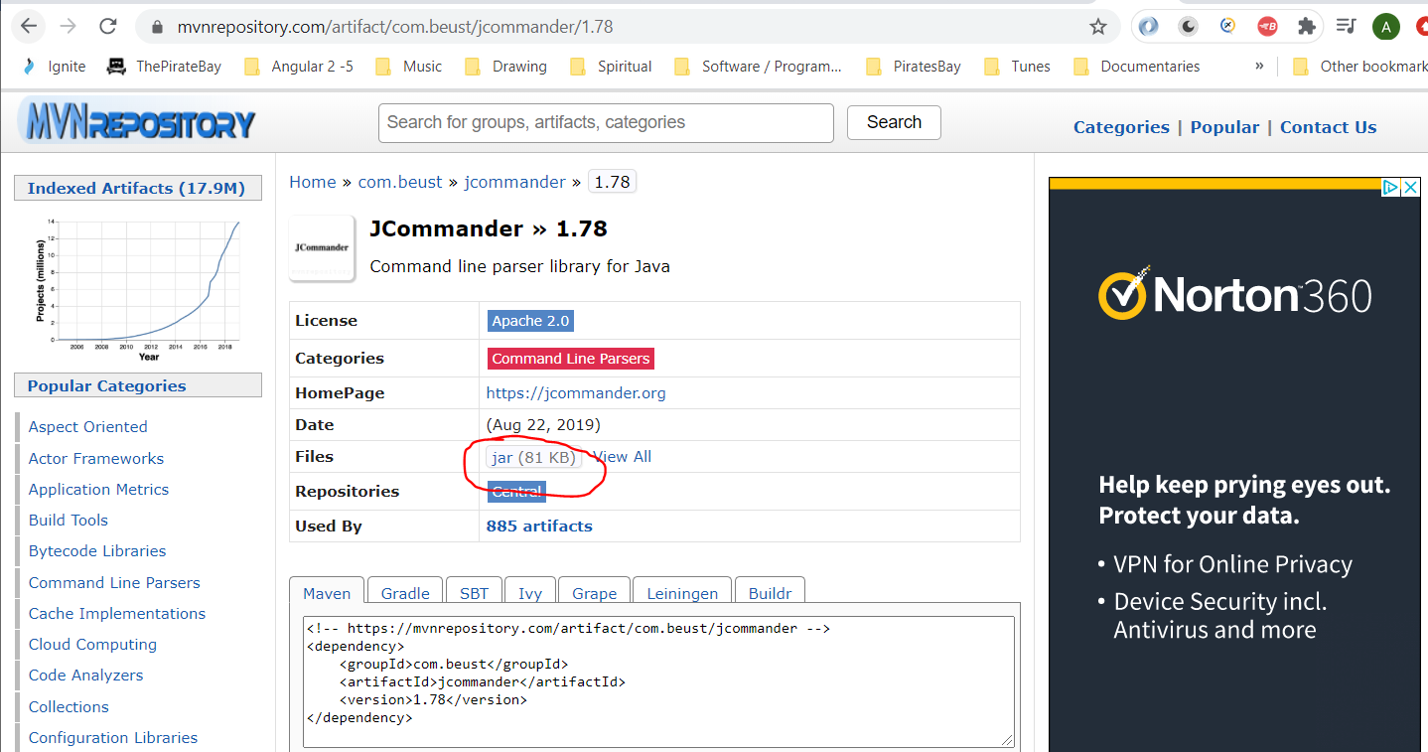

Add the external JAR.

**Dynamic JSON Payloads**

Use the Library API:-

BaseUrl:- <http://216.10.245.166>

Resoource:- Library/AddBook.php

Method:- POST

**First Step**

Create Requests in Postman:-

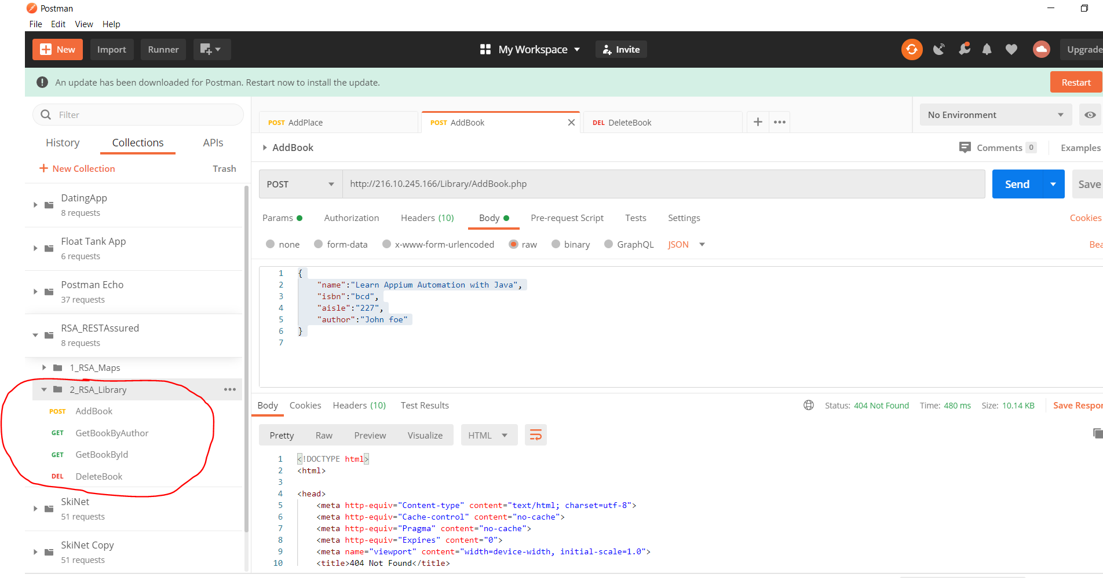

Now, create a new project within Eclipse:-

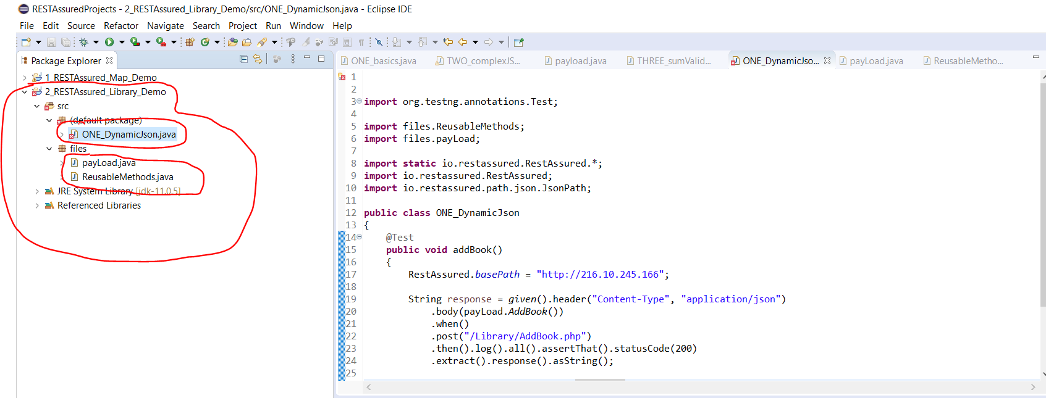

Add the package called ‘files’. Then create the classes underneath the project:-

**PayLoad**

**ReusableMethods**

Create the following test class under the ‘default package’:-

**DynamicJson**

Now make the payload class dynamic:-

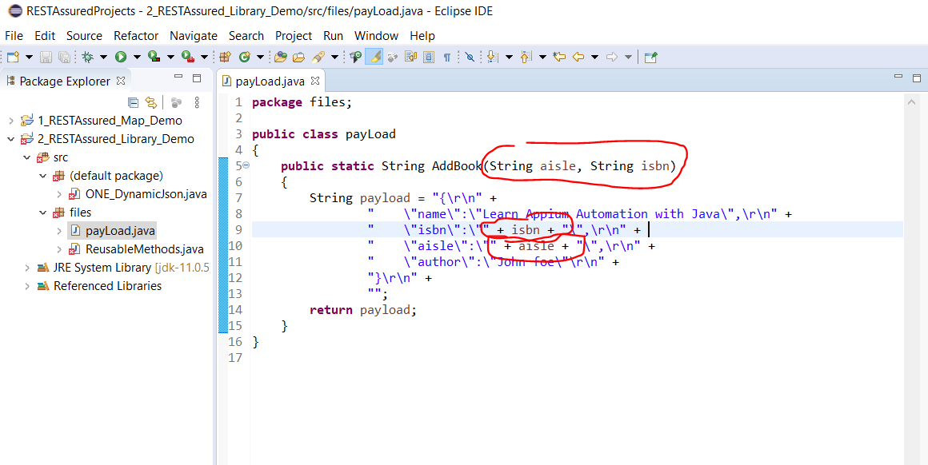

Pass strings in the test class:-

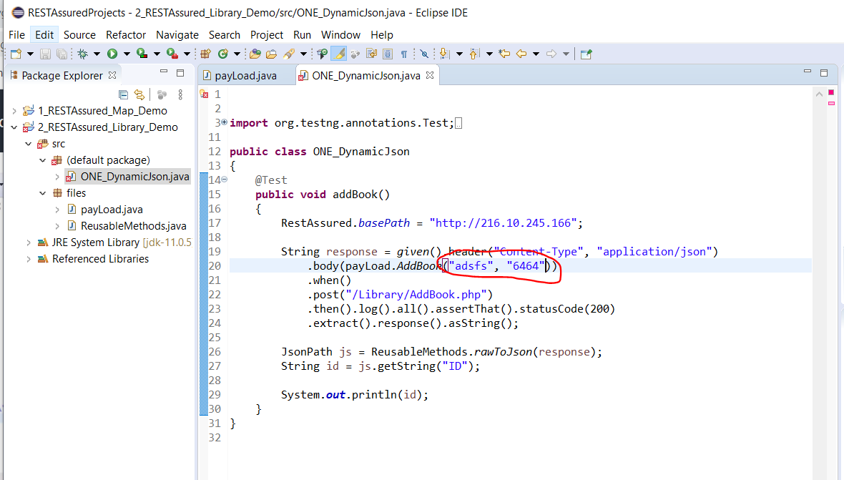

**TestNG Data Provider Annotation**

If you want the above tests to run multiple times with different test data i.e. adding books with different aisle and isbn number you need to use a ‘Data Provide’. See below:-

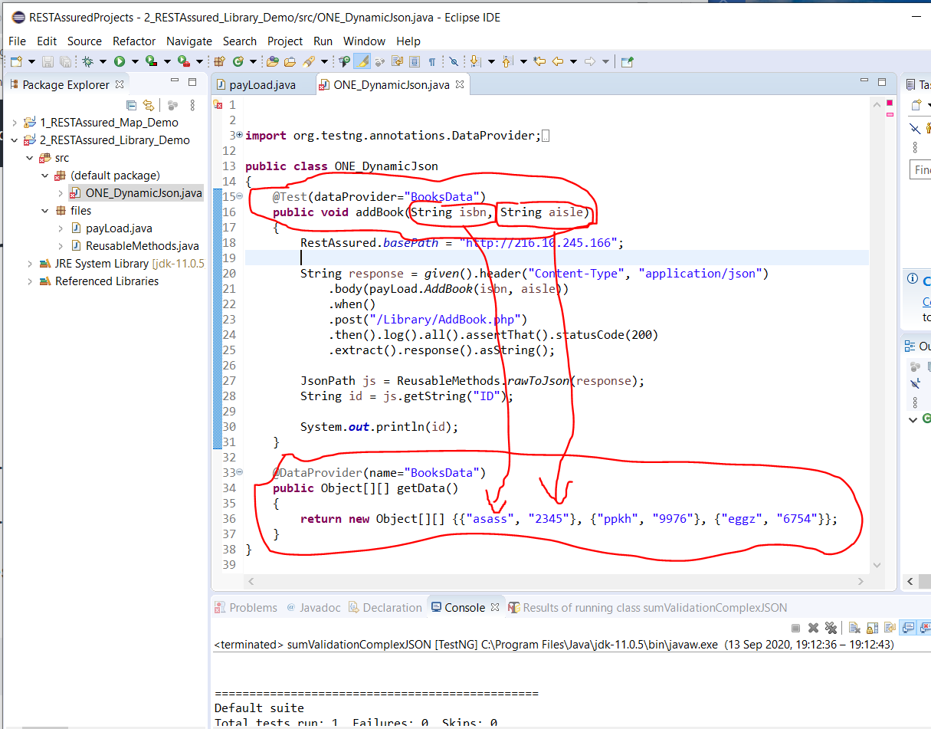

The above will run 3 times. Each time for each object in the Object array – Object[][].

Note:- Each object should have 2 parameter that should match the ‘addBook() parameters.

**Get Json Payload from a separate file**

First convert the content of the external JSON file to a string.

Json Payload file exists here:-

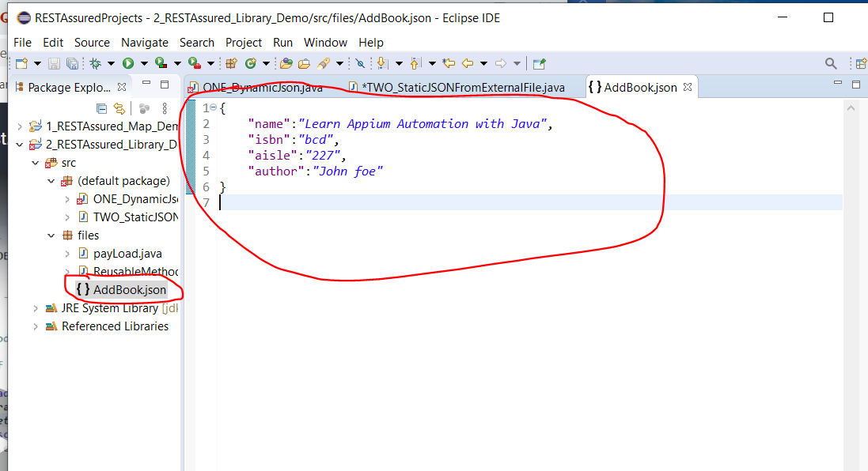

Create a new class and add this:-

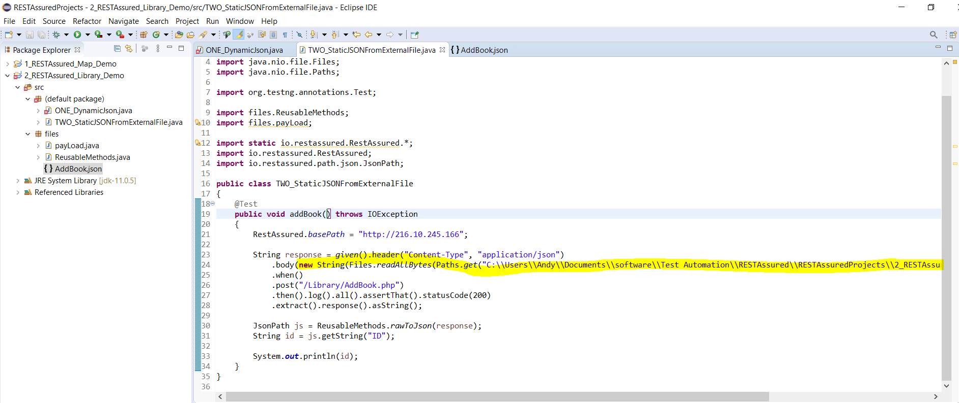

**Jira REST API**

<https://docs.atlassian.com/software/jira/docs/api/REST/7.6.1/>

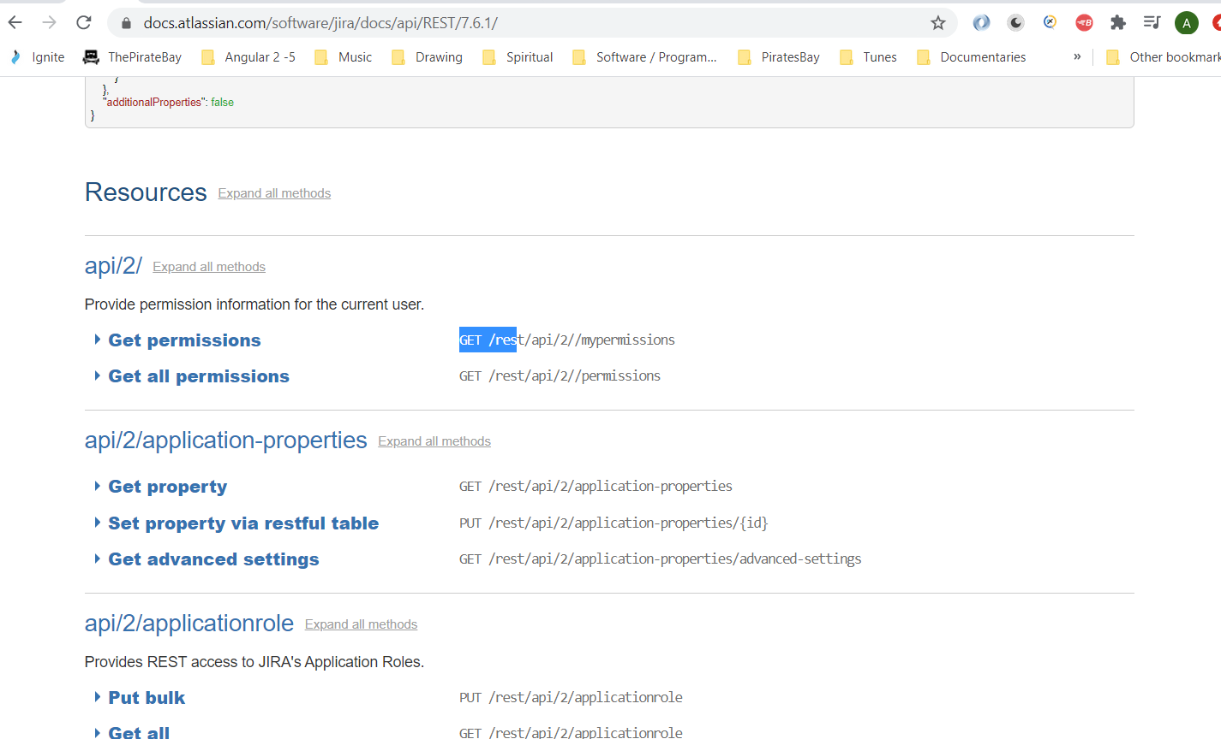

Download Jira from here:-

<https://www.atlassian.com/software/jira/download>

When installing just click next next next to install default settings. Install the cloud version.

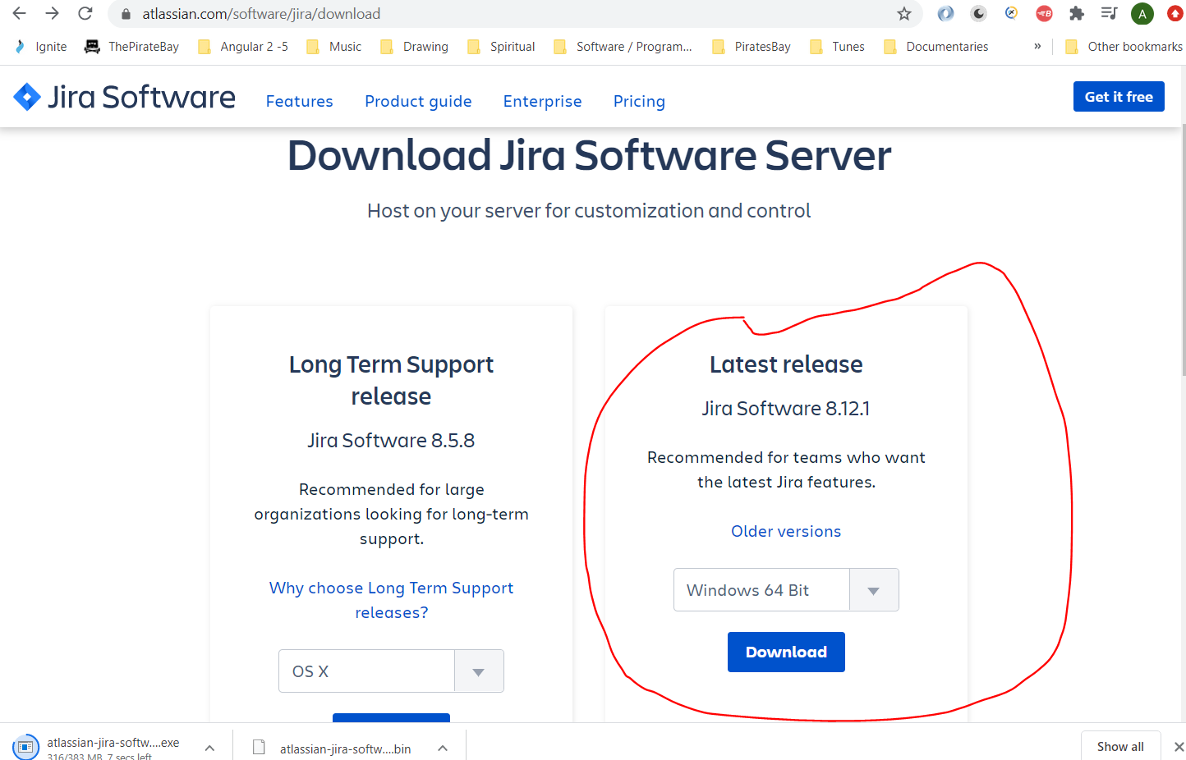

When installed you can access Jira by entering the following into the browser address bar:-

localhost:8080

Login credentials:-

Email:- [shortzenhausen@gmail.com](mailto:shortzenhausen@gmail.com)

ServerID:- BYOQ-SA1G-BB3I-QY5L

Organisation Name:- home

**Username:- Andy**

**Password:- dudeegg1977**

Below is a link to Jira cookie based authentication:-

<https://developer.atlassian.com/server/jira/platform/cookie-based-authentication/>

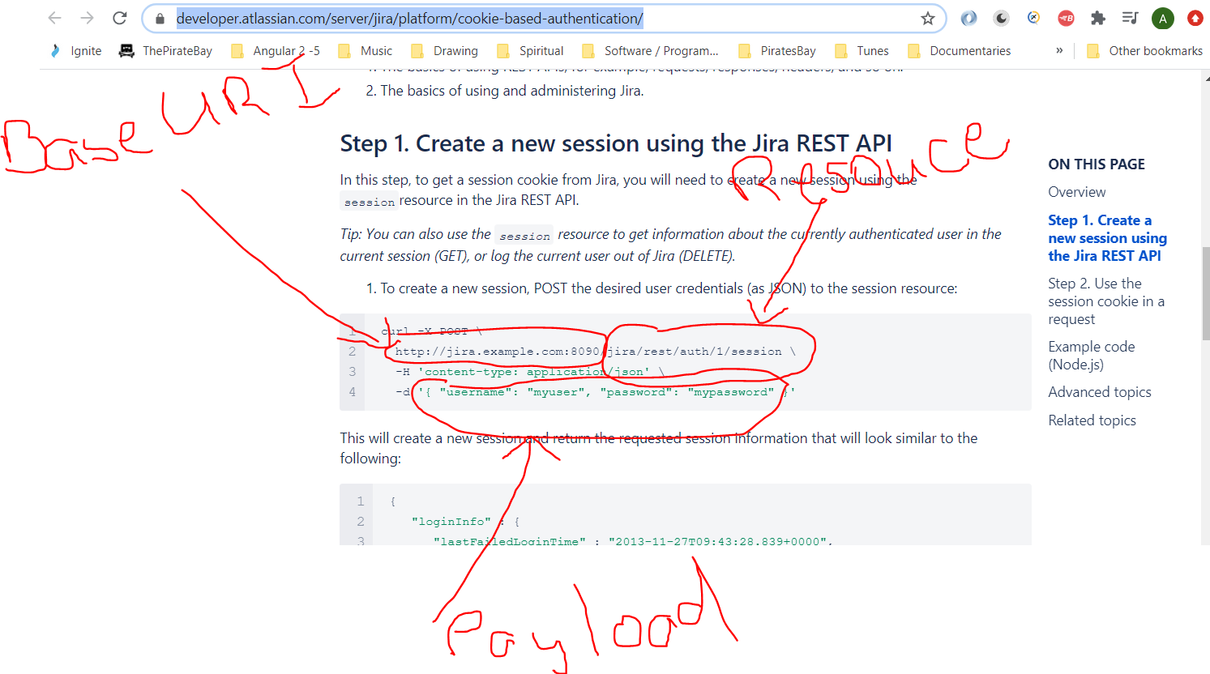

**Actually, BaseURI is - http://jira.example.com:8090/jira**

And,

**Resource is - /rest/auth/1/session**

For the base URI you need to remove the ‘jira’ part. So the BaseUri is this:-]

http://jira.example.com:8090/rest/auth/1/session

Response:-

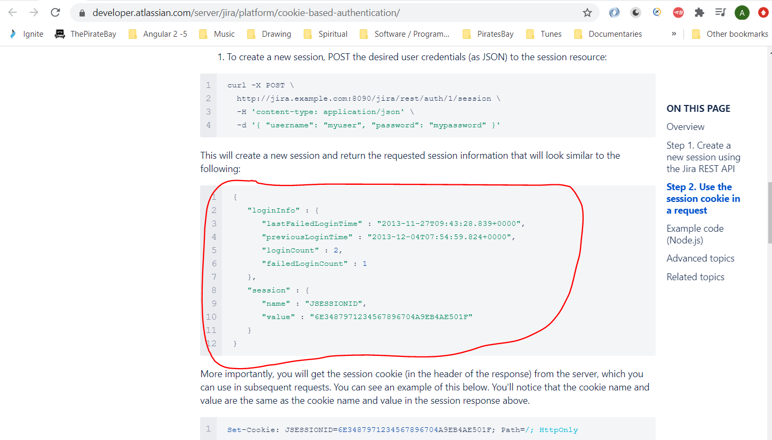

Use this in the header of requests in subsequent requests to the server:-

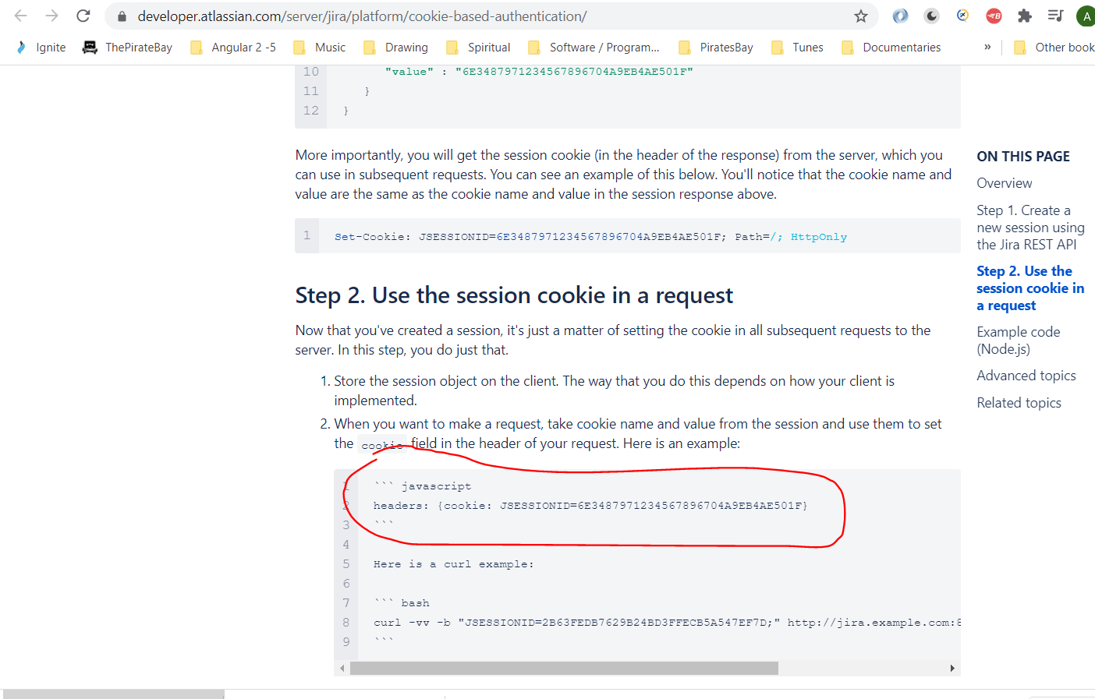

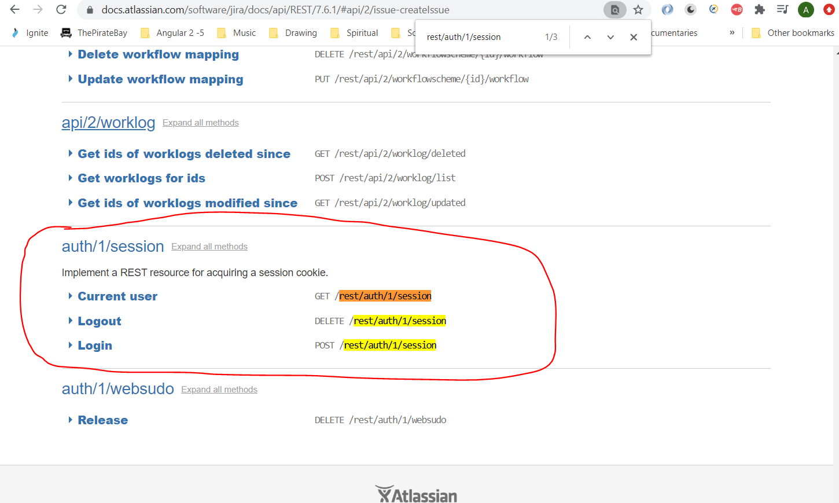

So, create a new Postman request:-

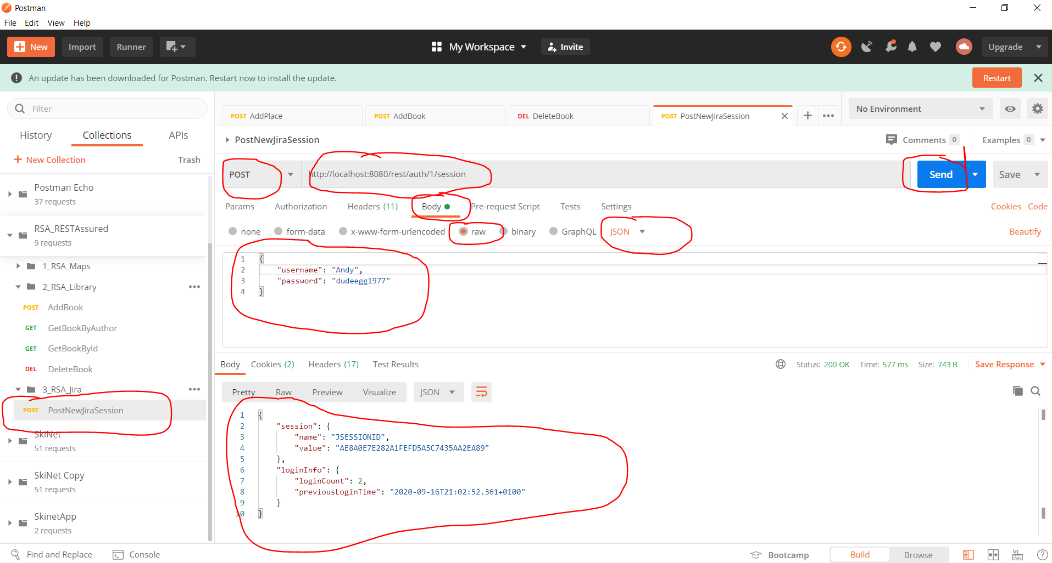

See response at the bottom (in the above screenshot).

Now you can use this sessionID for other requests:-

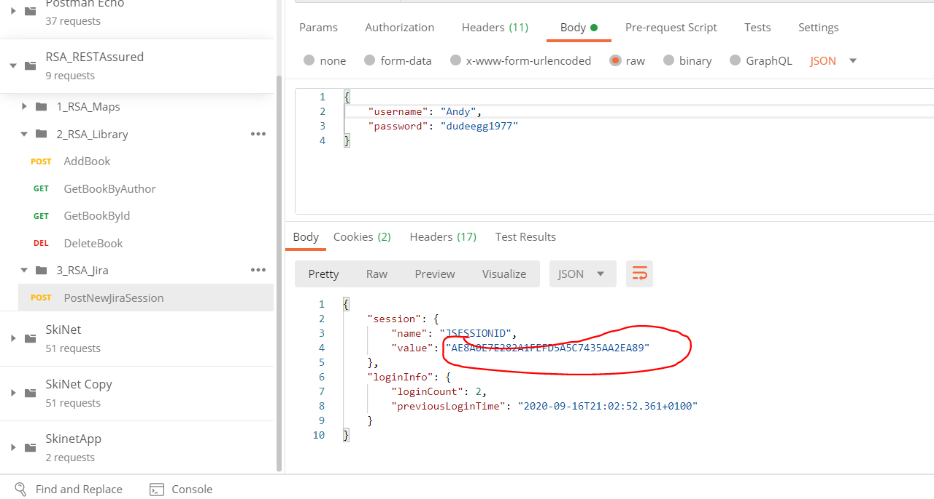

Go to Jiri API documentation (see link below) and go down to ‘Create issue’:-

<https://docs.atlassian.com/software/jira/docs/api/REST/7.6.1/#api/2/issue-createIssue>

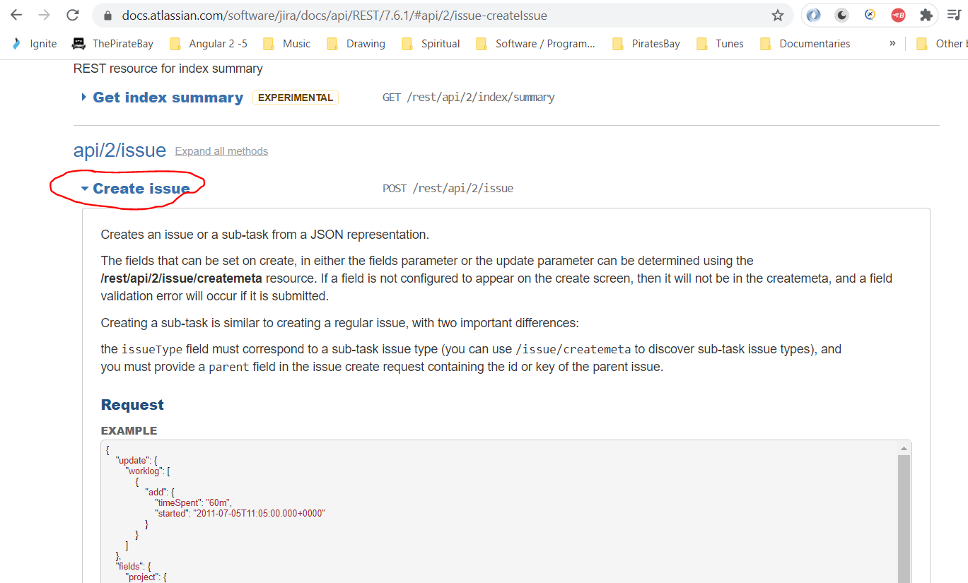

Create a new Postman request for creating a new Jira ‘Issue’ (bug). See this section of the Jira PI documentation:-

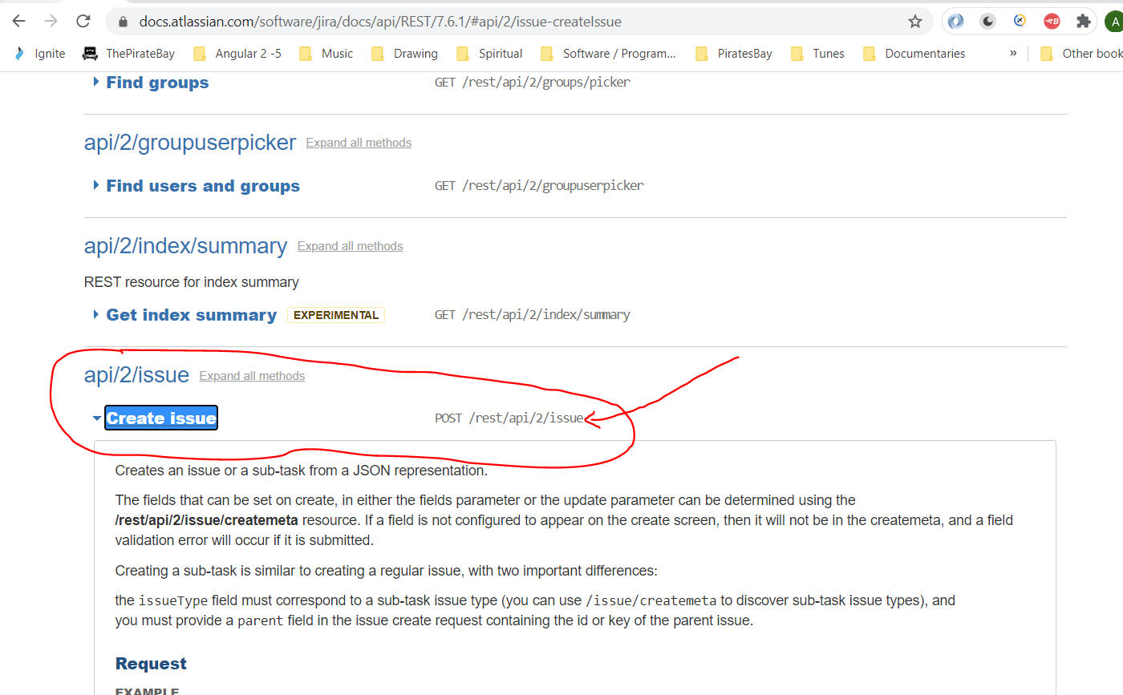

See Postman request below:-

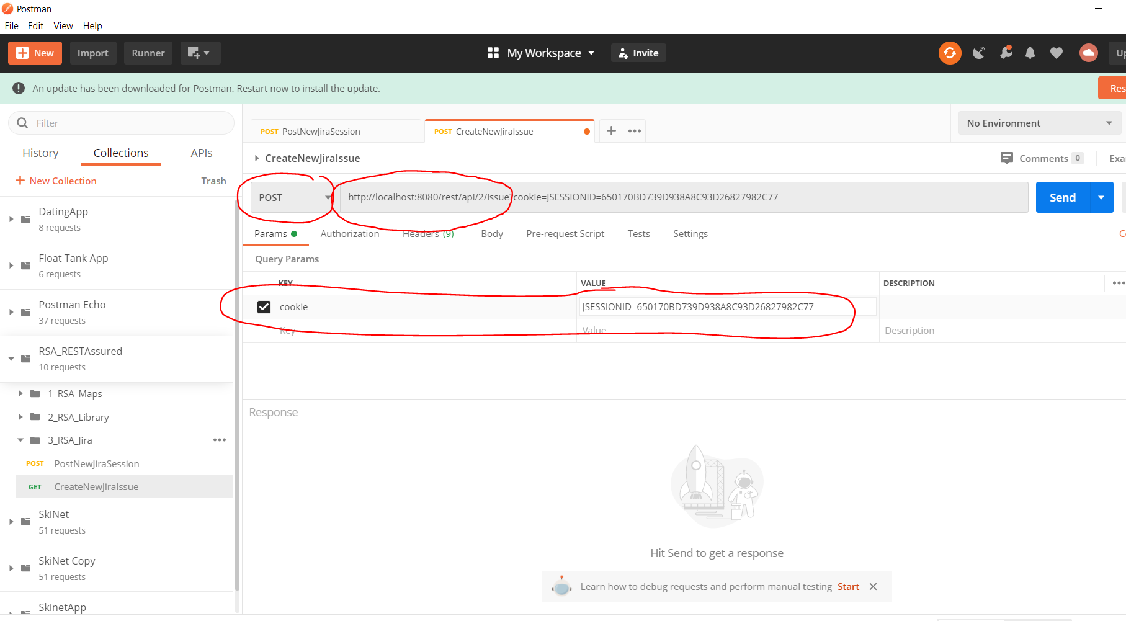

See the above ‘Params’ tab is made up of the cookie which is taken from the response of the ‘PostNewJiraSession’:-

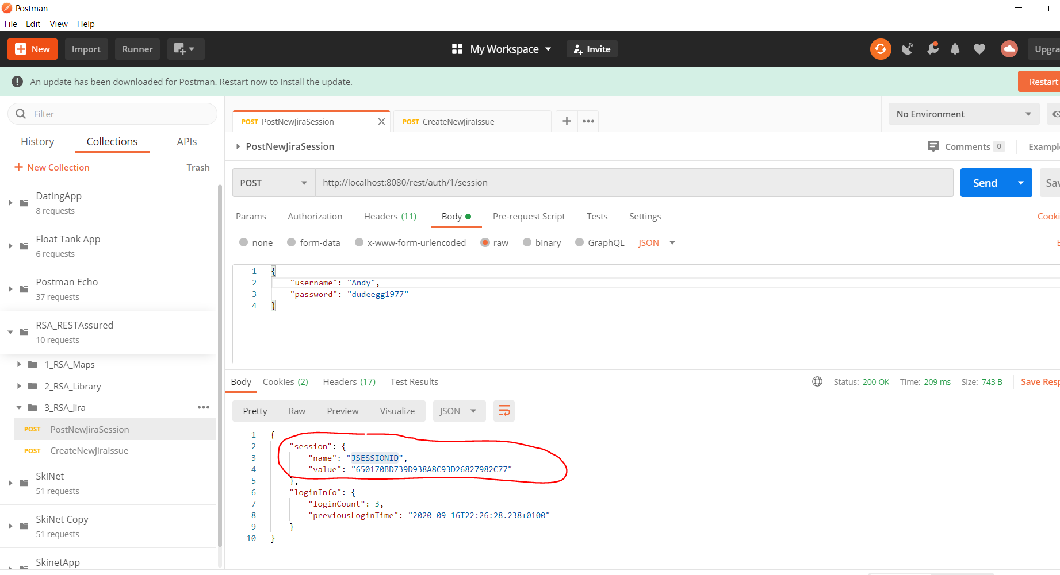

JSESSIONID=650170BD739D938A8C93D26827982C77

Now, add the body part of the Postman Request which will be written to Jira:-

